15455 Paseo Del Sur
San Diego, CA 92127
(858)759-1921

Del Sur Community

October 19, 2018

General Manager
Darryn Marshall
Darryn.marshall@fsresidential.com

Assistant Manager
Chris Malama
Christine.malama@fsresidential.com

Gigi Ochoa
Administrative Assistant
Gigi.ochoa@fsresidential.com

Del Sur Park
For reservations: 858-538-8131

ATLAS
Defense Group Patrol Services:
On-Site Officer (3pm to 11pm)
619-490-0012

Suspicious Activity:
San Diego Police Department
Non-Emergency Dispatch Line:
858-484-3154
FOR EMERGENCIES DIAL 9-1-1

San Diego County Animal Control:
619-767-2675
24-Hour Emergency:
619-236-2341

CUSTOMER CARE:

To Report After-Hours

Issues, Assessment

Questions OR Customer Care

(800)428-5588

Did you know? If you need to replace your trash cans you need to contact the City of San Diego if you live on a city street and Republic Services if you live on a private street. You can contact The City of San Diego by calling 858-694-7000 or by emailing our rep Angelica Miranda at almiranda@sandiego.gov. To contact Republic Services you may contact Shela Tussy by calling her at 760-508-5119 or by emailing her at stussy@republicservices.com.
PAINTING PROJECT: Several parks will undergo some painting in the next few weeks. The first areas will be Katherine Claire Pocket Park and it will be followed by Haaland Glen. During the painting process, we ask the community to please stay well clear of these areas. Painting will commence the week of October 16th at Katherine Claire and Haaland Glen. We will advise the commencement as the painter move onto each individual park thereafter.
Just a reminder: In San Diego, a dog that is brought into a public or private area where dogs are permitted must be restrained by a handheld leash no longer than six feet in length (San Diego County Code Sec. 63.0102(b)(2)), even if your dog is leashed, you must have the ability to control your dog at all times.
A dog owner or custodian must prevent the dog from being “at large” according to San Diego County Code 62.669. “At large” means being without a leash on public property. “Leash” means rope or similar material six feet or less in length. See sections (c) and (aa) of San Diego County Code 62.602. If you’re on public property, then your dog MUST have a leash.
What To Do About A Barking Dog?
Frequent dog barking is prohibited under San Diego Municipal Code section 59.50502(c). You should call San Diego Code Enforcement at (619) 236-5500 to complain.
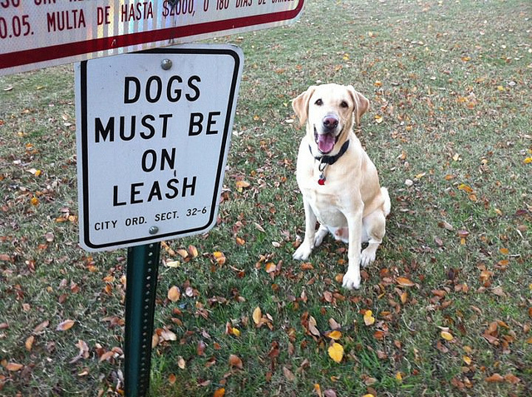

UPCOMING EVENTS:
Fall Festival Carnival for the adults only on Friday night!
Come enjoy carnival games, rides, food and drinks. Must be 21+ to attend this event.
RSVP: You must purchase a ticket to attend this event. You are required to show your Del Sur ID Card at our welcome table in order to attend the event. Even if you have purchased a ticket, if you do not have your ID card, we will refund your money and ask you to leave. This ensures that only CSC residents are attending this event.

Guests: Guests are not permitted at this event.  Tickets: Tickets will be on sale soon.  Bring: Your camera and cash to tip your bartenders. | The Village Green  Paseo Del Sur - San Diego  October 19, 2018  6:00 pm - 10:00 pm
For more information contact the CSC at info@delsurcsc.org or visit their website at www.delsurcsc.org

Ina Garten's Guacamole
Ingredients  4 ripe hass avocados  3 tablespoons freshly squeezed lemon juice (1 lemon)  8 dashes hot pepper sauce  1/2 cup small-diced red onion (1 small onion)  1 large garlic clove, minced  1 teaspoon kosher salt  1 teaspoon freshly ground black pepper  1 medium tomato, seeded and small-diced  Multigrain chips, for serving | Directions  - Cut the avocados in half, remove the pits and scoop the flesh out of their shells into a large bowl. Immediately add the lemon juice, hot pepper sauce, onion, garlic, salt and pepper and toss well. Using a sharp knife, slice through the avocados in the bowl until they are finely diced. Add the tomato. Mix well and taste for salt and pepper. Serve with chips.

Board Members
President:
Bill Ostrem
Vice President:
Lynn Miller
Treasurer/Secretary:
Tom Atkin
Director at Large:
Zubin Patrawala
Director at Large:
Ruth Loucks
The upcoming Executive Board Meeting is scheduled for October 30th at the Ranch House.
Executive session:
(Closed to homeowners) begins at 5:00 p.m.
Open Session:
Meeting is scheduled for
October 30th, 2018.
Regular Session (open to homeowners) begins at 6:30 p.m.
Design Review Committee:
Meetings are scheduled for the second Friday of each month with a deadline for submittal of the first Friday of each month. Please submit a Variance Request for all your minor exterior improvements to Chris Malama.

Please call Customer Care for any after-hours emergencies at
(800) 428-5588.
Management hopes that
everyone has a
safe and happy weekend!
AVARON:  FirstService Residential  Michelle Menne  michelle.menne@fsresidential.com  5473 Kearny Villa Rd.,  #200 San Diego, CA 92123  800-527-3914  direct: 858-657-2187  Rebekah Green  rebekah.green@fsresidential.com  858- 657-2199  CASSERO:  Packard Management  Dee Waite  dwaite@packard-1.com  9555 Chesapeake Dr., Ste. 202  San Diego, CA 92123  858-277-4305  Fax: 858-277-4308  GARRETSON:  FirstService Residential  Michelle Menne  michelle.menne@fsresidential.com  5473 Kearny Villa Rd., #200 San Diego, CA 92123  800-527-3914  direct: 858-657-2161  Brittany Walker  brittany.walker@fsresidential.com  (858) 657-2196 | AUBERGE:  FirstService Residential  Michelle Menne  michelle.menne@fsresidential.com  5473 Kearny Villa Rd.,#200  San Diego, CA 92123  800-527-3914  direct: 858-657-2161  Lisa Crawford  lisa.crawford@fsresidential.com  858- 657-2196  MANDOLIN:  Prescott Management  Jessika Rubalcava  jrubalcava@prescottmgt.com  16880 W. Bernardo Dr., Ste. 200  San Diego, CA 92127  Direct: 858-946-0320 ext. 7952  Kristen Saucedo (Assistant)  Kristen.saucedo@prescottmgt.com  CALATLANTIC HOMES (LENNAR)  HOMEOWNER HOTLINE:  (800) 509-4979  WILLIAM LYON HOMES CUSTOMER SERVICE  800-770-6883  BROOKFIELD HOMES HOMEOWNER HOTLINE:  (714) 200-7411

