15455 Paseo Del Sur
San Diego, CA 92127
(858)759-1921

Del Sur Community

October 26, 2018

General Manager
Darryn Marshall
Darryn.marshall@fsresidential.com

Assistant Manager
Chris Malama
Christine.malama@fsresidential.com

Gigi Ochoa
Administrative Assistant
Gigi.ochoa@fsresidential.com

Del Sur Park
For reservations: 858-538-8131

ATLAS
Defense Group Patrol Services:
On-Site Officer (3pm to 11pm)
619-490-0012

Suspicious Activity:
San Diego Police Department
Non-Emergency Dispatch Line:
858-484-3154
FOR EMERGENCIES DIAL 9-1-1

San Diego County Animal Control:
619-767-2675
24-Hour Emergency:
619-236-2341

CUSTOMER CARE:

To Report After-Hours

Issues, Assessment

Questions OR Customer Care

(800)428-5588

High-Rose Pool: Our vendor is diligently in the process of cleaning the pool after it was vandalized over the weekend. A Fire extinguisher was sprayed into the water, causing an oily film to float on top. Since the facility has a sand filter installed, the clean-up is going slowly and may need to be drained. Our vender has added clarifier and an oil remover to the water. We will keep you posted as we go through the week.
Beltaire Park: The plumber has notified us that the cylinders to the faucets in the restrooms are not working. Replacement cylinders have been ordered and will be installed by the plumber as soon as the new cylinders have been received. We appreciate your patience while we get this repaired.
PAINTING PROJECT: Several parks will undergo some painting in the next few weeks. The first areas will be Katherine Claire Pocket Park and it will be followed by Haaland Glen. During the painting process, we ask the community to please stay well clear of these areas. Painting will commence the week of October 16th at Katherine Claire and Haaland Glen. We will advise the commencement as the painter move onto each individual park thereafter.
Just a reminder: In San Diego, a dog that is brought into a public or private area where dogs are permitted must be restrained by a handheld leash no longer than six feet in length (San Diego County Code Sec. 63.0102(b) (2)), even if your dog is leashed, you must have the ability to control your dog at all times.
A dog owner or custodian must prevent the dog from being “at large” according to San Diego County Code 62.669. “At large” means being without a leash on public property. “Leash” means rope or similar material six feet or less in length. See sections (c) and (aa) of San Diego County Code 62.602. If you’re on public property, then your dog MUST have a leash.
What to Do About a Barking Dog?
Frequent dog barking is prohibited under San Diego Municipal Code section 59.50502(c). You should call San Diego Code Enforcement at (619) 236-5500 to complain.
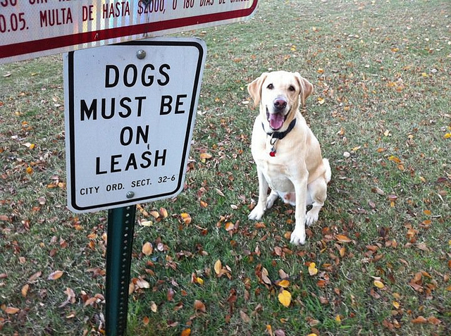

November 16, 2018 - November 18, 2018
What:
It’s time for Santa Photos in Del Sur! Mark your calendars! Be sure to sign up for your time slot!
Friday from 4pm-7:30pm | Saturday & Sunday from 12pm-5pm
Date(s) - November 16, 2018 - November 18, 2018
4:00 pm - 5:00 pm
Location
Del Sur Ranch House
15455 Paseo Del Sur
San Diego, CA 92127
UPCOMING EVENTS:

For more information contact the CSC at info@delsurcsc.org or visit their website at www.delsurcsc.org
Ingredients  For the Crust :  1 cup (2 sticks) unsalted butter cut into cubes-chilled  2 and 1/2 cups all-purpose flour  1 teaspoon salt  1 teaspoon sugar  4 Tablespoons ice water  (or you can use 1 package Refrigerated Pie Crust (2 crusts))  For filling and topping:  3/4 cup reduced pumpkin puree (place 1 cup pumpkin puree on several layers of paper towel, wrap and press to soak excess moisture until you get 3/4 cup pumpkin puree)  2 oz. cream cheese -slightly softened  2 tablespoons packed light-brown sugar  2 tablespoons granulated sugar  1 teaspoon ground cinnamon  1/2 teaspoon ground ginger  1/4 teaspoon of nutmeg  1/8 teaspoon allspice  1 egg yolk  1/2 teaspoon vanilla extract  1 egg white-lightly beaten  1/2 tablespoon water  2 tablespoon sugar  1 teaspoon cinnamon | Instructions:  To make the crust pulse together in a food processor flour, salt and sugar, then add butter and pulse until look like a coarse meal (don’t over-process, just pulse until butter is no longer in large pieces). Add chilled water 1-2 tablespoon at the time and pulse several times (if it doesn’t come together in clumps add remaining water). If you don’t have a food processor you can make the dough using two fork or pastry blender. Gather dough onto working surface, divide into two portions, and shape each into 5-inch disk, cover with plastic wrap and chill 1 hour.  To make the pumpkin pie filling in a bowl stir together cream cheese, granulated sugar and brown sugar to blend. Add reduced pumpkin puree to cream cheese mixture along with cinnamon, ginger, nutmeg and allspice. Mix in egg yolk and vanilla extract. Cover bowl and chill until ready to assemble the cookies.  Preheat oven to 375 F and line large baking sheet with parchment paper, set aside.  To assemble the mummies:  Roll out first disk of the dough onto a floured surface to about 13 x 11-inch rectangle. If the edges start to crack a little when rolling, seal them and continue rolling. Trim edges to get straight edges, then cut into rectangles. Roll out second dough disc and cut into 1/2 inch stripes.  Arrange the rectangles, spaced apart on prepared baking sheet and spread heaping 1 1/2-2 tablespoons of pumpkin pie filling onto each rectangle, leaving rim on all sides uncoated. Brush uncoated edges with the mixture of lightly beaten egg white and 1 Tbsp. water. Top with strips to create mummy look, then seal edges with your fingertips, and trim the excess of the stripes. Brush the stripes with egg whites and sprinkle with mixture of 2 Tbsp. sugar and 1 tsp. cinnamon.  Bake until golden brown about 20 minutes.  Stick candy eyes onto cooled mummies.

Mummy Pumpkin Cookies

Board Members
President:
Bill Ostrem
Vice President:
Lynn Miller
Treasurer/Secretary:
Tom Atkin
Director at Large:
Zubin Patrawala
Director at Large:
Ruth Loucks
The upcoming Executive Board Meeting is scheduled for October 30th at the Ranch House.
Executive session:
(Closed to homeowners) begins at 5:00 p.m.
Open Session:
Meeting is scheduled for
October 30th, 2018.
Regular Session (open to homeowners) begins at 6:30 p.m.
Design Review Committee:
Meetings are scheduled for the second Friday of each month with a deadline for submittal of the first Friday of each month. Please submit a Variance Request for all your minor exterior improvements to Chris Malama.

Please call Customer Care for any after-hours emergencies at
(800) 428-5588.
Management hopes that
everyone has a
safe and happy weekend!
AVARON:  FirstService Residential  Michelle Menne  michelle.menne@fsresidential.com  5473 Kearny Villa Rd.,  #200 San Diego, CA 92123  800-527-3914  direct: 858-657-2187  Rebekah Green  rebekah.green@fsresidential.com  858- 657-2199  CASSERO:  Packard Management  Dee Waite  dwaite@packard-1.com  9555 Chesapeake Dr., Ste. 202  San Diego, CA 92123  858-277-4305  Fax: 858-277-4308  GARRETSON:  FirstService Residential  Michelle Menne  michelle.menne@fsresidential.com  5473 Kearny Villa Rd., #200 San Diego, CA 92123  800-527-3914  direct: 858-657-2161  Brittany Walker  brittany.walker@fsresidential.com  (858) 657-2196 | AUBERGE:  FirstService Residential  Michelle Menne  michelle.menne@fsresidential.com  5473 Kearny Villa Rd.,#200  San Diego, CA 92123  800-527-3914  direct: 858-657-2161  Lisa Crawford  lisa.crawford@fsresidential.com  858- 657-2196  MANDOLIN:  Prescott Management  Jessika Rubalcava  jrubalcava@prescottmgt.com  16880 W. Bernardo Dr., Ste. 200  San Diego, CA 92127  Direct: 858-946-0320 ext. 7952  Kristen Saucedo (Assistant)  Kristen.saucedo@prescottmgt.com  CALATLANTIC HOMES (LENNAR)  HOMEOWNER HOTLINE:  (800) 509-4979  WILLIAM LYON HOMES CUSTOMER SERVICE  800-770-6883  BROOKFIELD HOMES HOMEOWNER HOTLINE:  (714) 200-7411

