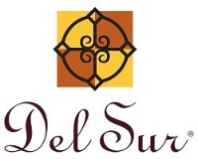
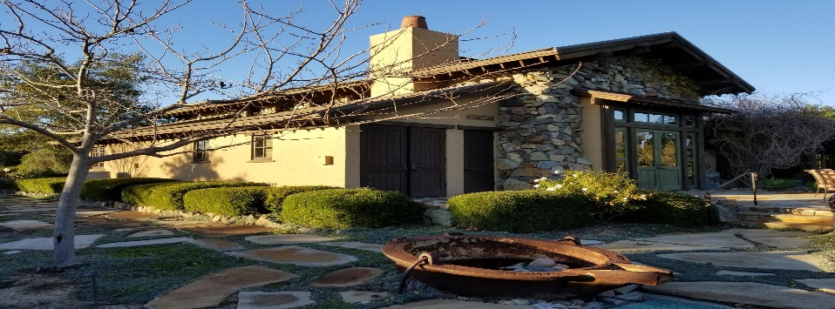
February 1, 2019
15455 Paseo Del Sur
San Diego, CA 92127
(858) 759-1921

General Manager
Darryn Marshall Darryn.marshall@fsresidential.com

Assistant Manager
Chris Malama Christine.malama@fsresidential.com

Administrative Assistant Gigi Ochoa Gigi.ochoa@fsresidential.com

Del Sur Neighborhood Park
15816 Paseo Montenero (Owned and operated by the City of San Diego)

For reservations, information or to report an incident please call:
858-538-8131

ATLAS
Defense Group Patrol Services: On-Site Officer (3pm to 11pm) 619-490-0012

Suspicious Activity:
San Diego Police Department
Non-Emergency Dispatch Line:
858-484-3154
FOR EMERGENCIES DIAL 9-1-1

San Diego County Animal Control: 619-767-2675
24-Hour Emergency: 619-236-2341
CUSTOMER CARE:
To Report After-Hours Issues, Assessment Questions OR Customer Care
(800)428-5588

Your Opinion Counts: The association has sent out, via the community website, a survey that contains important information to the way landscape maintenance is performed. We are requesting that residents that have not yet registered on the website to do so prior to February 23rd so you can submit your feedback on this topic, if you are registered, your participation and feedback is also appreciated. This is an opinion based survey where the results may be used to assist the Del Sur Board of Directors on how to proceed with landscape maintenance in the future.

It is important for all residents to register on the website and to complete the survey. Registering on the community website keeps you up to date with the latest, enables management to send future surveys, and enables you to utilize the community website to its full potential.

To participate in the current survey, you will need to register, or already be registered on the Community website. To register, please visit www.delsurcommunity.org. Further information will be available when you log on. If you have any questions please reach out to management at 858-759-1921.

Swim lessons: With swimming lessons approaching quickly, registration for all swim instructors has begun. All Swim instructors will need to fill out the attached Swim Instructor Registration form. This form MUST be completed and returned to the HOA office before any swimming lessons commence, along with their Insurance naming Del Sur Community Association as additionally insured. All student waivers must be submitted from all residents. Swim instructors will be required to come into the Ranch House to obtain a new ID card.

Signage: We have noticed an increase of posted ads for services and events on the mailboxes and streetlights. As a reminder, the Community Guidelines: Section D Sign Guidelines, page 5, Subject to Civil Code Section 712 and 713 states,, no sign, advertising device or other display of any kind shall be displayed in the community or on any public street in or abutting the community. All violators will be sent a violation letter.

Wine Tasting:
When: April 13, 2019
Time: 6:00 pm - 9:00 pm
Where: Del Sur Ranch House
15455 Paseo Del Sur
San Diego, CA 92127

What: Featuring local wineries, Del Sur residents will get a chance to taste wine paired with delicious bites. Bottles will be available to purchase. Once you have tasted them all, head over to our bar to sip on a glass of your favorite.
Note: We love throwing these adult socials! Please be responsible and be sure to have a sober ride home or plan on walking. We want to ensure that everyone has a great time and gets home safe!
RSVP: You must purchase a ticket to attend this event. You are required to show your Del Sur ID Card at our welcome table in order to attend the event. Even if you have purchased a ticket, if you do not have your ID card, we will refund your money and ask you to leave.
RSVP
Please note: Only CSC residents are allowed to attend this event. Guests are not permitted at this event.
Tickets: Tickets will be on sale soon at www.delsurcsc.org.

Low-Cal Fettuccine Alfredo
Ingredients:  1 tablespoon unsalted butter  1 clove garlic, minced  1 teaspoon grated lemon zest  2 teaspoons all-purpose flour  1 cup low-fat (2%) milk  Kosher salt  2 tablespoons Neufchtel or low-fat cream cheese  3/4 cup grated parmesan cheese, plus more for topping  3 tablespoons chopped fresh parsley  12 ounces fresh fettuccine  Freshly ground pepper | Directions  Make the sauce: Melt the butter in a skillet over medium heat. Add the garlic and lemon zest and cook until the garlic is slightly soft, about 1 minute. Add in the flour and cook, stirring with a wooden spoon, 1 minute. Whisk in the milk and 3/4 teaspoon salt and cook, whisking constantly, until just thickened, about 3 minutes. Add the Neufchatel and parmesan cheese; whisk until melted, about 1 minute. Stir in the chopped parsley. Meanwhile, bring a large pot of salted water to a boil. Add the fettuccine and cook until al dente, 2 to 3 minutes. Reserve 1 cup cooking water, then drain the pasta and return to the pot. Add the sauce and 1/2 cup of the reserved cooking water to the pasta and gently toss to combine, adding more cooking water as needed to loosen. Season with salt. Divide among bowls and top with parmesan and pepper.

Community Services Council vs Del Community Association

Did you know that the CSC is independent from the Del Sur Community Association and both entities have their own areas of responsibility?

 |  | CSC | DEL SUR COMMUNITY ASSOCIATION
Boards |  | 5 Directors | 5 Directors
Purpose |  | - Funds & organizes all Community Events, including Movie Nights, Concerts, Holiday Events, etc.  - Promotes and supports resident Driven  Community Clubs | - Upkeep and Maintenance of common areas: including private parks, mail boxes, etc.  - Enforcement of Covenants, Conditions and Restrictions  - Oversee Design Review
Source of Funds |  | Enhancement Fee on the Sale of  homes in Del Sur | Monthly HOA Dues
Meeting Schedule |  | Meet quarterly – 4th Wednesday  – January, April, July & October (April & October are in the evening and open to CSC residents. | Monthly Executive meetings: Open session board meetings are now being held on the 4th Tuesday of every odd month (Mar, May, Jul, Sept, and Nov). See www.delsurcommunity.org for  details
Fiscal Year |  | June – May | June - May
Website |  | www.delsurcsc.org – For all  Event and Reservation Information | www.delsurcommunity.org – For all Association related Information

AVARON:  FirstService Residential  Jose Cortez jose.cortez@fsresidential.com 5473 Kearny Villa Rd.,  #200 San Diego, CA 92123  800-527-3914  direct: 858-657-2180  Rebekah Green rebekah.green@fsresidential.com 858- 657-2188  CASSERO:  Packard Management Dee Waite dwaite@packard-1.com  9555 Chesapeake Dr., Ste. 202 San Diego, CA 92123  858-277-4305  Fax: 858-277-4308  GARRETSON:  FirstService Residential Michelle Menne michelle.menne@fsresidential.com  5473 Kearny Villa Rd., #200 San Diego, CA 92123  800-527-3914  direct: 858-657-2161  SKYE:  Community Manager: Elena Mendenhall elaina.mendonhall@fsredidential.com  858-657-2194  Assistant: Judi Abdon  Judi.abdon@fsresidential.com  858-657-2186  5473 Kearny Villa Rd.,  #200 San Diego, CA 92123 | AUBERGE:  FirstService Residential  Michelle Menne michelle.menne@fsresidential.com  5473 Kearny Villa Rd.,#200  San Diego, CA 92123 800-527-3914  direct: 858-657-2161  Lisa Crawford  lisa.crawford@fsresidential.com  858- 657-2196  MANDOLIN:  Prescott Management  Jessika Rubalcava  jrubalcava@prescottmgt.com  16880 W. Bernardo Dr., Ste. 200  San Diego, CA 92127  Direct: 858-946-0320 ext. 7952  Kristen Saucedo (Assistant)  Kristen.saucedo@prescottmgt.com  AVANTE’:  Elena Mendenhall elaina.mendonhall@fsredidential.com  858-657-2194  Judi Abdon  Judi.abdon@fsresidential.com  858-657-2186  5473 Kearny Villa Rd.,  #200 San Diego, CA 92123  CALATLANTIC HOMES (LENNAR) HOMEOWNER HOTLINE:  (800) 509-4979  WILLIAM LYON HOMES CUSTOMER SERVICE  800-770-6883  BROOKFIELD HOMES HOMEOWNER HOTLINE:  (714) 200-7411 | Board Members  President:  Bill Ostrem  Vice President:  Lynn Miller  Treasurer/Secretary:  Tom Atkin  Director at Large:  Zubin Patrawala  Director at Large:  Ruth Loucks  BOARD MEETINGS  Executive Session:  The next meeting is scheduled for Tuesday, February 26, 2019 at 5:00 pm at the  Ranch House.  Executive session meetings are closed to homeowners  .  Open Session:  Open session board meetings are now being held on the 4th Tuesday of every odd month (Mar, May, Jul, Sept, and Nov).  Next Open Session Meeting:  Tuesday, March 26, 2019  at 6:30 pm.  Design Review Committee  Meetings are scheduled for the second Friday of each month with a deadline for submittal of the first Friday of each month. Please submit Variance Requests and supporting documents for all your minor exterior improvements to Chris Malama @ christine.malama@fsresidential.com  .
Please call Customer Care for any
after-hours emergencies at
(800) 428-5588.
Management hopes that everyone has
a safe and happy weekend!

