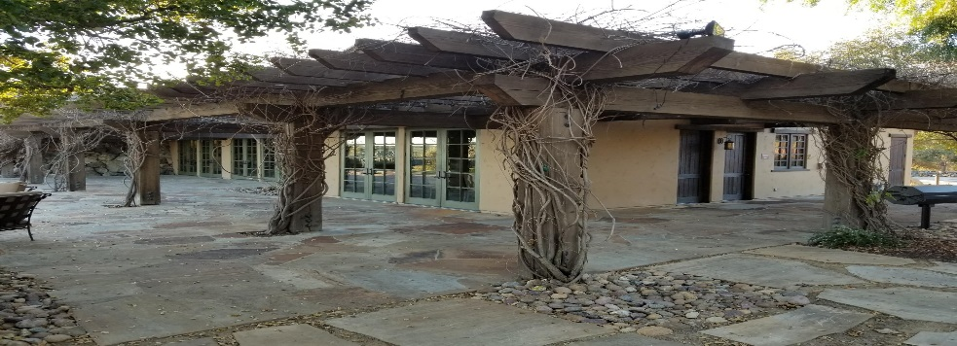
February 8, 2019
15455 Paseo Del Sur
San Diego, CA 92127
(858) 759-1921

General Manager
Darryn Marshall Darryn.marshall@fsresidential.com

Assistant Manager
Chris Malama Christine.malama@fsresidential.com

Administrative Assistant Gigi Ochoa Gigi.ochoa@fsresidential.com

Del Sur Neighborhood Park
15816 Paseo Montenero (Owned and operated by the City of San Diego)

For reservations, information or to report an incident please call:
858-538-8131

ATLAS
Defense Group Patrol Services: On-Site Officer (3pm to 11pm) 619-490-0012

Suspicious Activity:
San Diego Police Department
Non-Emergency Dispatch Line:
858-484-3154
FOR EMERGENCIES DIAL 9-1-1

San Diego County Animal Control: 619-767-2675
24-Hour Emergency: 619-236-2341
CUSTOMER CARE:
To Report After-Hours Issues, Assessment Questions OR Customer Care
(800)428-5588

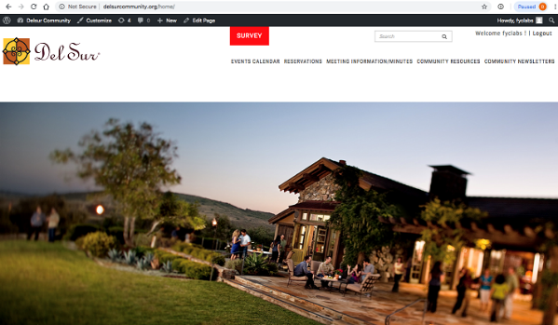
IMPORTANTANT INFORMATION: POSSIBLE INCREASE IN MONTHLY DUES!!

The Board of Directors is asking that all residents participate in an opinion survey regarding the possible implementation of Natural Landscape Maintenance, which could result in an increase in monthly dues. The purpose of the survey is to gather your thoughts on this service to enable the Board to make an informed decision on this topic. It is extremely important that any resident that has not registered on the community website do so as soon as possible so you are kept up to date on Association matters and to participate in any additional surveys that directly affect residents on such matters as rule change, assessment increases etc. Please register on the association website and submit your opinion prior to February 23rd.

To participate in the current survey, you will need to register, or already be registered on the Community website. To register, please visit www.delsurcommunity.org. Once your registration has been approved you will receive an email notification asking you to log on and select a password. The next step is to select the SURVEY button at the top of the home page to cast your opinion. If you have any questions or need assistance logging on please reach out to management at 858-759-1921.

Swim lessons: With swimming lessons approaching quickly, registration for all swim instructors has begun. All Swim instructors will need to fill out the attached Swim Instructor Registration form. (These forms are also available on the community website.) This form MUST be completed and returned to the HOA office before any swimming lessons commence, along with their Insurance naming Del Sur Community Association as additionally insured. All student waivers must be submitted from all residents. Swim instructors will be required to come into the Ranch House to obtain a new ID card.
It has come to our attention that trash is being left in the park areas, specifically the play structures. This oversight will eventually attract bugs, rodents and other animals. It is important that we all pick up our trash and place it in the provided trash cans to prevent this problem.

We thank you for your cooperation.

Wine Tasting:
When: April 13, 2019
Time: 6:00 pm - 9:00 pm
Where: Del Sur Ranch House
15455 Paseo Del Sur
San Diego, CA 92127

What: Featuring local wineries, Del Sur residents will get a chance to taste wine paired with delicious bites. Bottles will be available to purchase. Once you have tasted them all, head over to our bar to sip on a glass of your favorite.
Note: We love throwing these adult socials! Please be responsible and be sure to have a sober ride home or plan on walking. We want to ensure that everyone has a great time and gets home safe!
RSVP: You must purchase a ticket to attend this event. You are required to show your Del Sur ID Card at our welcome table in order to attend the event. Even if you have purchased a ticket, if you do not have your ID card, we will refund your money and ask you to leave.
RSVP
Please note: Only CSC residents are allowed to attend this event. Guests are not permitted at this event.
Tickets: Tickets will be on sale soon at www.delsurcsc.org.

Old-Fashioned Chicken Pot Pie

How to Make It  Step 1  Combine first 7 ingredients in a large Dutch oven; bring to a boil. Cover, reduce heat, and simmer 1 hour or until chicken is tender. Remove chicken, reserving broth in Dutch oven; discard vegetables and bay leaf. Let chicken cool; skin, bone, and cut into bite-size pieces.  Step 2  With a large spoon, skim fat (oily liquid) from surface of broth reserved in Dutch oven; bring broth to a boil. Add frozen vegetables and potatoes; return to a boil. Reduce heat, cover, and simmer 8 minutes or until tender. Remove vegetables from broth, and set aside. Measure 3 cups broth; set aside. Reserve remaining broth for other uses. | Step 3  Melt butter in Dutch oven over low heat; add flour, stirring until smooth. Cook 1 minute, stirring constantly. Gradually add 3 cups broth and milk; cook over medium heat, stirring constantly, until mixture is thickened and bubbly. Stir in 11/2 teaspoons salt, 11/4 teaspoons pepper, and thyme. Add vegetables, chicken, and hard-cooked eggs; stir gently. Spoon into a lightly greased 13- x 9- x 2-inch baking dish; set aside.  Step 4  Roll out piecrust on a lightly floured surface into a 15- x 11-inch rectangle (piecrust will be very thin). Place over chicken mixture; crimp edges, pressing against sides of baking dish. Cut slits in top for steam to escape; bake at 400° for 20 minutes or until golden brown.
Ingredients:

1 (3 1/2-pound) broiler fryer
2 quarts water
1 teaspoon salt
1/2 teaspoon pepper
1 stalk celery, cut into 2-inch pieces
1 medium onion, quartered
1 bay leaf
1 (16-ounce) package frozen mixed vegetables
2 large potatoes, peeled and cubed
1/2 cup butter or margarine
1/2 cup all-purpose flour
1 cup milk
1 1/2 teaspoons salt
1 1/4 teaspoons pepper
1/4 teaspoon dried thyme
2 hard-cooked eggs, sliced
1 (9-inch) refrigerated piecrust

Community Services Council vs Del Community Association

Did you know that the CSC is independent from the Del Sur Community Association and both entities have their own areas of responsibility?

 |  | CSC | DEL SUR COMMUNITY ASSOCIATION
Boards |  | 5 Directors | 5 Directors
Purpose |  | - Funds & organizes all Community Events, including Movie Nights, Concerts, Holiday Events, etc.  - Promotes and supports resident Driven  Community Clubs | - Upkeep and Maintenance of common areas: including private parks, mail boxes, etc.  - Enforcement of Covenants, Conditions and Restrictions  - Oversee Design Review
Source of Funds |  | Enhancement Fee on the Sale of  homes in Del Sur | Monthly HOA Dues
Meeting Schedule |  | Meet quarterly – 4th Wednesday  – January, April, July & October (April & October are in the evening and open to CSC residents. | Monthly Executive meetings: Open session board meetings are now being held on the 4th Tuesday of every odd month (Mar, May, Jul, Sept, and Nov). See www.delsurcommunity.org for  details
Fiscal Year |  | June – May | June - May
Website |  | www.delsurcsc.org – For all  Event and Reservation Information | www.delsurcommunity.org – For all Association related Information

AVARON:  FirstService Residential  Jose Cortez jose.cortez@fsresidential.com 5473 Kearny Villa Rd.,  #200 San Diego, CA 92123  800-527-3914  direct: 858-657-2180  Rebekah Green rebekah.green@fsresidential.com 858- 657-2188  CASSERO:  Packard Management Dee Waite dwaite@packard-1.com  9555 Chesapeake Dr., Ste. 202 San Diego, CA 92123  858-277-4305  Fax: 858-277-4308  GARRETSON:  FirstService Residential Michelle Menne michelle.menne@fsresidential.com  5473 Kearny Villa Rd., #200 San Diego, CA 92123  800-527-3914  direct: 858-657-2161  SKYE:  Community Manager: Elena Mendenhall elaina.mendonhall@fsredidential.com  858-657-2194  Assistant: Judi Abdon  Judi.abdon@fsresidential.com  858-657-2186  5473 Kearny Villa Rd.,  #200 San Diego, CA 92123 | AUBERGE:  FirstService Residential  Michelle Menne michelle.menne@fsresidential.com  5473 Kearny Villa Rd.,#200  San Diego, CA 92123 800-527-3914  direct: 858-657-2161  Lisa Crawford  lisa.crawford@fsresidential.com  858- 657-2196  MANDOLIN:  Prescott Management  Jessika Rubalcava  jrubalcava@prescottmgt.com  16880 W. Bernardo Dr., Ste. 200  San Diego, CA 92127  Direct: 858-946-0320 ext. 7952  Kristen Saucedo (Assistant)  Kristen.saucedo@prescottmgt.com  AVANTE’:  Elena Mendenhall elaina.mendonhall@fsredidential.com  858-657-2194  Judi Abdon  Judi.abdon@fsresidential.com  858-657-2186  5473 Kearny Villa Rd.,  #200 San Diego, CA 92123  CALATLANTIC HOMES (LENNAR) HOMEOWNER HOTLINE:  (800) 509-4979  WILLIAM LYON HOMES CUSTOMER SERVICE  800-770-6883  BROOKFIELD HOMES HOMEOWNER HOTLINE:  (714) 200-7411 | Board Members  President:  Bill Ostrem  Vice President:  Lynn Miller  Treasurer/Secretary:  Tom Atkin  Director at Large:  Zubin Patrawala  Director at Large:  Ruth Loucks  BOARD MEETINGS  Executive Session:  The next meeting is scheduled for Tuesday, February 26, 2019 at 5:00 pm at the  Ranch House.  Executive session meetings are closed to homeowners  .  Open Session:  Open session board meetings are now being held on the 4th Tuesday of every odd month (Mar, May, Jul, Sept, and Nov).  Next Open Session Meeting:  Tuesday, March 26, 2019 at 6:30 pm.  Design Review Committee  Meetings are scheduled for the second Friday of each month with a deadline for submittal of the first Friday of each month. Please submit Variance Requests and supporting documents for all your minor exterior improvements to Chris Malama @ christine.malama@fsresidential.com  .
Please call Customer Care for any
after-hours emergencies at
(800) 428-5588.
Management hopes that everyone has
a safe and happy weekend!

