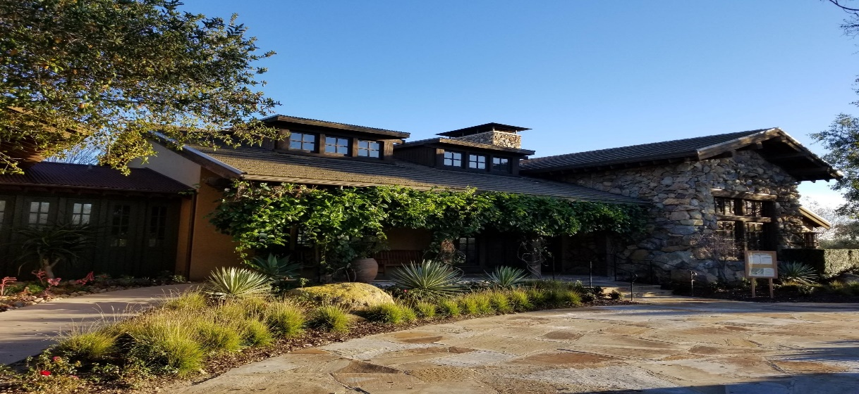
March 29, 2019
15455 Paseo Del Sur
San Diego, CA 92127
(858) 759-1921

General Manager
Darryn Marshall Darryn.marshall@fsresidential.com

Assistant Manager
Chris Malama Christine.malama@fsresidential.com

Administrative Assistant
Gigi Ochoa
Gigi.ochoa@fsresidential.com

~~~~~~~~~~~~~~~~~~~~~~~~~~~~~~~~~

Del Sur Neighborhood Park
15816 Paseo Montenero (Owned and operated by
the City of San Diego)

For reservations, information or to

report an incident please call:
858-538-8131
~~~~~~~~~~~~~~~~~~~~~~~~~~~
ATLAS
Defense Group Patrol Services: On-Site Officer (3pm to 11pm) 619-490-0012
~~~~~~~~~~~~~~~~~~~~~~~~~~
Suspicious Activity:
San Diego Police Department
Non-Emergency Dispatch Line:
858-484-3154
FOR EMERGENCIES DIAL 9-1-1
~~~~~~~~~~~~~~~~~~~~~~~~~
San Diego County Animal Control:
619-767-2675
24-Hour Emergency: 619-236-2341
~~~~~~~~~~~~~~~~~~~~~~~~
CUSTOMER CARE:
To Report After-Hours Issues, Assessment Questions OR Customer Care
(800) 428-5588

.
CONCRETE REPAIRS: The concrete repairs at Spreckels Park have been completed. The second phase of repairs will take place on Spreckels Lane and Spreckels Place. Schedule yet to be determined.
TRASH CONTAINERS: We continue to receive complaints that many residents are continuing to leave their trash cans out for several days. Management and the Board would appreciate your cooperation by following the Community Guidelines for trash cans.
Trash containers may be set out at curbside for a reasonable period of time (not to exceed twelve (12) hours) on trash collection days. At all other times, owners must store trash containers in the garage or in an area designed for such storage behind a wall or fence which completely screens the trash containers from public view or view of neighbors, until scheduled collection times.
AUBREY PARK SLIDE: We have received a notification that the slide has been shipped and should be arriving sometime this coming week. The installer has yet to determine the installation date. We will keep you posted.
HAALAND GLEN PLAYSTRUCTURE: Per the manufacturer, the play structure is almost complete with an anticipated ship date of April 17th. We have begun to coordinate with the installer to have it installed in a timely manner. Your patience is greatly appreciated.

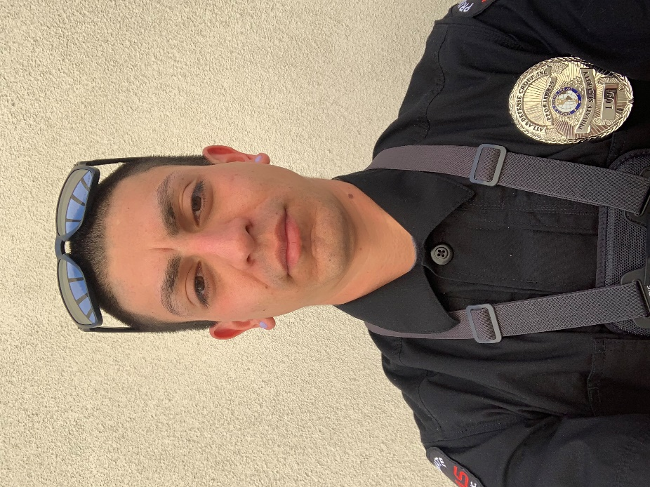
Meet Diego: The Del Sur Community Patrol.

The Del Sur Community Association would like to introduce the community to Diego, our on-site roving patrol person. Diego began serving the Del Sur Community November of 2018. Diego was born and raised in Whittier, California and moved to San Diego in 2001. Diego is a father of a 5-year-old son, and outside of work he enjoys hunting and fishing. He is seeking to enter into a career in law enforcement with either SDPD or San Diego Sheriff’s.

Diego is our full-time roving patrol person who is on-site Monday - Friday from 3pm-11pm. He is responsible for patrolling the community, checking community pools and parks, enforcing HOA policies, and preventing trespassing, vandalism and any other unwanted activities in the community. If you have any questions or need assistance, feel free to contact the dedicated Del Sur community phone line at (619) 490-0012.

Wine Tasting:
When: April 13, 2019
Time: 6:00 pm - 9:00 pm
Where: Del Sur Ranch House
15455 Paseo Del Sur
San Diego, CA 92127

What: Featuring local wineries, Del Sur residents will get a chance to taste wine paired with delicious bites. Bottles will be available to purchase. Once you have tasted them all, head over to our bar to sip on a glass of your favorite.
Note: We love throwing these adult socials! Please be responsible and be sure to have a sober ride home or plan on walking. We want to ensure that everyone has a great time and gets home safe!
RSVP: You must purchase a ticket to attend this event. You are required to show your Del Sur ID Card at our welcome table in order to attend the event. Even if you have purchased a ticket, if you do not have your ID card, we will refund your money and ask you to leave.
RSVP
Please note: Only CSC residents are allowed to attend this event. Guests are not permitted at this event.
Tickets: Tickets will be on sale soon at www.delsurcsc.org.

The Del Sur Educational Foundation Night at The Ranch Event!

Everyone is invited to join us on Saturday, April 6th at the Del Sur Ranch House as we Rock Through the Ages in support of Del Sur Elementary.

Tickets and additional information about the event can be found at https://events.handbid.com. You will need to first register or log in with your existing HANDBID account. Search for Del Sur-Night at the Ranch 2019 event and click on Buy Tickets.

Community Services Council vs Del Community Association

Did you know that the CSC is independent from the Del Sur Community Association and both entities have their own areas of responsibility?

 |  | CSC | DEL SUR COMMUNITY ASSOCIATION
Boards |  | 5 Directors | 5 Directors
Purpose |  | - Funds & organizes all Community Events, including Movie Nights, Concerts, Holiday Events, etc.  - Promotes and supports resident Driven  Community Clubs | - Upkeep and Maintenance of common areas: including private parks, mail boxes, etc.  - Enforcement of Covenants, Conditions and Restrictions  - Oversee Design Review
Source of Funds |  | Enhancement Fee on the Sale of  homes in Del Sur | Monthly HOA Dues
Meeting Schedule |  | Meet quarterly – 4th Wednesday  – January, April, July & October (April & October are in the evening and open to CSC residents. | Monthly Executive Meetings:  Open Session Meetings:  Are now being held on the 4th Tuesday of every odd month (Jan, Mar, May, Jul, Sept, and Nov). See www.delsurcommunity.org for details
Fiscal Year |  | June – May | June - May
Website |  | www.delsurcsc.org – For all  Event and Reservation Information | www.delsurcommunity.org – For all Association related Information

AVARON:  FirstService Residential  Jose Cortez jose.cortez@fsresidential.com 5473 Kearny Villa Rd.,  #200 San Diego, CA 92123  direct: 858-657-2180  Rebekah Green rebekah.green@fsresidential.com 858- 657-2188  CASSERO:  Packard Management Dee Waite dwaite@packard-1.com  9555 Chesapeake Dr., Ste. 202 San Diego, CA 92123  858-277-4305  GARRETSON:  FirstService Residential  Michelle Menne michelle.menne@fsresidential.com  5473 Kearny Villa Rd., #200  San Diego, CA 92123  direct: 858-657-2161  Lisa Crawford  lisa.crawford@fsresidential.com  858- 657-2196  SKYE:  Community Manager: Elena Mendenhall elaina.mendonhall@fsredidential.com  858-657-2194  Assistant: Judi Abdon  Judi.abdon@fsresidential.com  858-657-2186  5473 Kearny Villa Rd.,  #200 San Diego, CA 92123 | AUBERGE:  Keystone Pacific  Marty Ignacio  MIgnacio@keystonepacific.com  1801 W. Olympic Blvd  Pasadena, CA 91199  Direct: 949-833-2600  MANDOLIN:  Prescott Management  Jessika Rubalcava  jrubalcava@prescottmgt.com  16880 W. Bernardo Dr., Ste. 200  San Diego, CA 92127  Direct: 858-946-0320 ext. 7952  Kristen Saucedo (Assistant)  Kristen.saucedo@prescottmgt.com  AVANTE’:  Elena Mendenhall elaina.mendonhall@fsredidential.com  858-657-2194  Judi Abdon  Judi.abdon@fsresidential.com  858-657-2186  5473 Kearny Villa Rd.,  #200 San Diego, CA 92123  CALATLANTIC HOMES (LENNAR) HOMEOWNER HOTLINE:  (800) 509-4979  WILLIAM LYON HOMES CUSTOMER SERVICE  800-770-6883  BROOKFIELD HOMES HOMEOWNER HOTLINE:  (714) 200-7411 | Board Members:  President:  Bill Ostrem  Vice President:  Lynn Miller  Director at Large:  Zubin Patrawala  Director at Large:  Ruth Loucks  Director at Large:  Hollie Kahn  BOARD MEETINGS  Executive Session:  The next meeting is scheduled for Tuesday, April 23, 2019 at 5:00 pm at the  Ranch House.  Executive session meetings are closed to homeowners  .  Open Session:  Open session board meetings are now being held on the 4th Tuesday of every odd month (Jan, Mar, May, Jul, Sept, and Nov).  Next Open Session Meeting:  Tuesday, May 28, 2019  at 6:30 pm.  Design Review Committee:  Meetings are scheduled for the second Friday of each month with a deadline for submittal of the first Friday of each month. Please submit Variance Requests and supporting documents for all your minor exterior improvements to Chris Malama at christine.malama@fsresidential.com  .
Please call Customer Care for any
after-hours emergencies at
(800) 428-5588.
Management hopes that everyone has
a safe and happy weekend!

