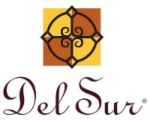
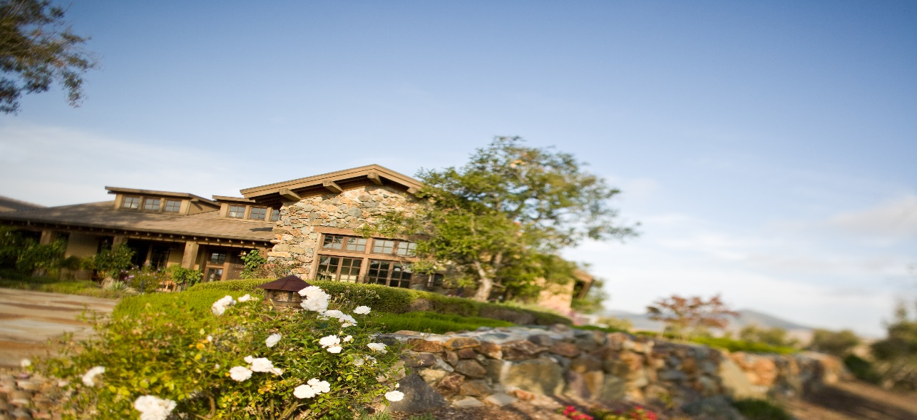
October 4, 2019
15455 Paseo Del Sur
San Diego, CA 92127
(858) 759-1921

General Manager

Darryn Marshall

Darryn.Marshall@fsresidential.com
Facilities Manager
Charlie Mullins
Charles.Mullins@fsresidential.com

Assistant Manager
Chris Malama
Christine.malama@fsresidential.com

Administrative Assistant
Gigi Ochoa
Gigi.Ochoa@fsresidential.com
~~~~~~~~~~~~~~~~~~~~~~~~~~~~~~~~~

Del Sur Neighborhood Park
15816 Paseo Montenero (Owned and operated by
the City of San Diego)

For reservations, information or to

report an incident please call:
858-538-8131
~~~~~~~~~~~~~~~~~~~~~~~~~~~
ATLAS
Defense Group Patrol Services: On-Site Officer (3pm to 11pm) 619-490-0012
~~~~~~~~~~~~~~~~~~~~~~~~~~
Suspicious Activity:
San Diego Police Department
Non-Emergency Dispatch Line:
858-484-3154
FOR EMERGENCIES DIAL 9-1-1
~~~~~~~~~~~~~~~~~~~~~~~~~
San Diego County Animal Control:
619-767-2675
24-Hour Emergency: 619-236-2341 ~~~~~~~~~~~~~~~~~~~~~~~~
CUSTOMER CARE:
To Report After-Hours Issues, or Assessment Questions
(800) 428-5588

.

Pickleball in Del Sur: Are you interested in playing outdoor pickleball without having to drive to the coast? The game is no longer considered just for the over-60 crowd, today’s youth are loving it too. The City of san Diego Parks and recreation Department has asked that we get a sense of the level of interest in playing Pickleball to have it accessible right here in Del Sur. Please send us an email noting the number of residents in your home who are interested in playing.

PLEASE CLEAN UP AFTER YOUR PET
We have received numerous complaints concerning residents not cleaning up after their pets. It is the responsibility of all pet owners to pick up after their pets. Please advise everyone in your household who walks your pet(s), that the association’s governing documents clearly state that pet owners are responsible for their pet’s waste. For your convenience, there are pet waste stations located at all the parks, with bags available. If you notice that a waste station is out of bags, please inform Management.

REPLACEMENT OF ADDRESS NUMBERS
Please be advised that it is the homeowner’s responsibility to make sure address numbers are attached and can be seen clearly on the front of the home and if an alleyway home, affixed to the garage. Please see below contact information to replace any damaged or missing address numbers for your home.

For any further information including ordering bronze address plates, please contact:
Rick Sweeney
OmniGraphicsSD.com
260 West Douglas Ave
El Cajon CA 92020
619.792-1350

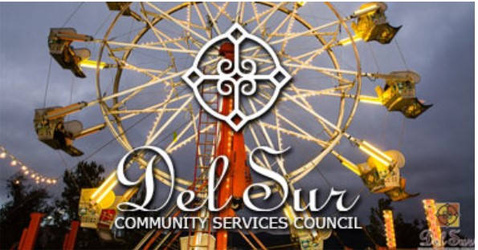
FALL FESTIVAL
When: October 4, 2019 at 6:00 pm - 10:00 pm
What: We are opening up our Fall Festival Carnival for the adults only on Friday night! Come enjoy carnival games, rides, food and drinks. Must be 21+ to attend this event.
Food: Delicious carnival food and a San Diego Food Truck. All food will be available for purchase.
Attire: Dress warm. This is an outdoor event with no heaters.
Note: We love throwing these adult socials! Please be responsible and be sure to have a sober ride home or plan on walking. We want to ensure that everyone has a great time and gets home safe!
RSVP: You must purchase a ticket to attend this event. You are required to show your Del Sur ID Card at our welcome table in order to attend the event. Even if you have purchased a ticket, if you do not have your ID card, we will refund your money and ask you to leave. This ensures that only CSC residents are attending this event.
Guests: Guests are permitted at this event, so bring some friends if you would like!
Tickets: Tickets are on sale now.
Location:
The Village Green
Paseo Del Sur
San Diego, CA 92127

Questions: Contact the CSC at info@delsurcsc.org

Community Services Council vs Del Community Association

Did you know that the CSC is independent from the Del Sur Community Association and both entities have their own areas of responsibility?

 |  | CSC | DEL SUR COMMUNITY ASSOCIATION
Boards |  | 5 Directors | 5 Directors
Purpose |  | - Funds & organizes all Community Events, including Movie Nights, Concerts, Holiday Events, etc.  - Promotes and supports resident Driven  Community Clubs | - Upkeep and Maintenance of common areas: including private parks, mail boxes, etc.  - Enforcement of Covenants, Conditions and Restrictions  - Oversee Design Review
Source of Funds |  | Enhancement Fee on the Sale of  homes in Del Sur | Monthly HOA Dues
Meeting Schedule |  | Meet quarterly – 4th Wednesday  – January, April, July & October (April & October are in the evening and open to CSC residents. | Monthly Executive Meetings:  Open Session Meetings:  Are now being held on the 4th Tuesday of every odd month (Jan, Mar, May, Jul, Sept, and Nov). See www.delsurcommunity.org for details
Fiscal Year |  | June – May | June - May
Website |  | www.delsurcsc.org – For all  Event and Reservation Information | www.delsurcommunity.org – For all Association related Information

AVARON:  FirstService Residential  Lisa Silva lisa.silva@fsresidential.com  5473 Kearny Villa Rd.,  #200 San Diego, CA 92123  Direct: 619-798-9110  CASSERO:  Packard Management Dee Waite dwaite@packard-1.com  9555 Chesapeake Dr., Ste. 202 San Diego, CA 92123  858-277-4305  GARRETSON:  FirstService Residential  Michelle Menne michelle.menne@fsresidential.com  5473 Kearny Villa Rd., #200  San Diego, CA 92123  direct: 858-657-2161  Lisa Crawford  lisa.crawford@fsresidential.com  858- 657-2196  SKYE:  Community Manager:  Elena Mendenhall elena.mendenhall@fsredidential.com  858-657-2194  Assistant: Judi Abdon  Judi.abdon@fsresidential.com  858-657-2186  5473 Kearny Villa Rd.,  #200 San Diego, CA 92123 | AUBERGE:  Keystone Pacific  Marty Ignacio  MIgnacio@keystonepacific.com  1801 W. Olympic Blvd  Pasadena, CA 91199  Direct: 619-798-9110  MANDOLIN:  Prescott Management  Jessika Rubalcava  jrubalcava@prescottmgt.com  16880 W. Bernardo Dr., Ste. 200  San Diego, CA 92127  Direct: 858-946-0320 ext. 7952  Kristen Saucedo (Assistant)  Kristen.saucedo@prescottmgt.com  AVANTE’:  Elena Mendenhall elena.mendenhall@fsredidential.com  858-657-2194  Judi Abdon  Judi.abdon@fsresidential.com  858-657-2186  5473 Kearny Villa Rd.,  #200 San Diego, CA 92123  CALATLANTIC HOMES (LENNAR) HOMEOWNER HOTLINE:  (800) 509-4979  WILLIAM LYON HOMES CUSTOMER SERVICE  800-770-6883  BROOKFIELD HOMES HOTLINE  CALIFORNIA CUSTOMER CARE:  800-399-0490  CONTACT@CACUSTOMERCARE.COM | Board Members:  President:  Bill Ostrem  Vice President:  Lynn Miller  Director at Large:  Alex Plishner  Director at Large:  Ruth Loucks  Director at Large:  Hollie Kahn  BOARD MEETINGS  Executive Session:  The next meeting is scheduled for Tuesday, October 22nd, 2019 at 5:00 pm at the Ranch House.  Executive session meetings are closed to homeowners  Open Session:  Open session board meetings are now being held on the 4th Tuesday of every odd month (Jan, Mar, May, Jul, Sept, and Nov).  Next Open Session Meeting:  Tuesday, November 26th, 2019  at 6:30 pm.  Design Review Committee:  Meetings are scheduled for the second Friday of each month with a deadline for submittal of the first Friday of each month. Please submit Variance Requests and supporting documents for all your minor exterior improvements to Chris Malama at christine.malama@fsresidential.com.
Please call Customer Care for any
after-hours emergencies at
(800) 428-5588. Management
hopes that everyone has
a safe and happy weekend!

