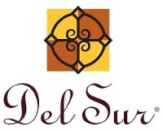
15455 Paseo Del Sur
San Diego, CA 92127
(858) 759-1921
January 10th, 2020

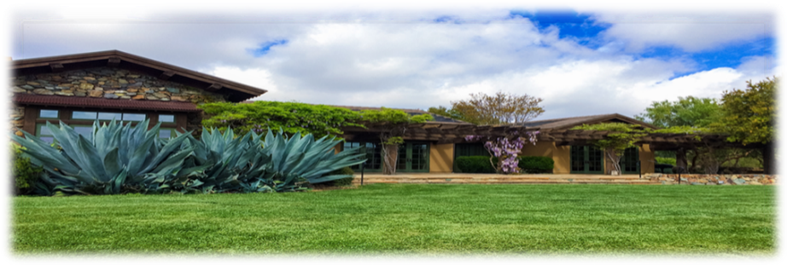

General Manager

Darryn Marshall

Darryn.Marshall@fsresidential.com
Facilities Manager
Charlie Mullins
Charles.Mullins@fsresidential.com

Assistant Manager
Chris Malama
Christine.malama@fsresidential.com

Administrative Assistant
Gigi Ochoa
Gigi.Ochoa@fsresidential.com

~~~~~~~~~~~~~~~~~~~~~~~~~~~~~~~

Del Sur Neighborhood Park
15816 Paseo Montenero
(Owned and operated by the City of San Diego)

For reservations, information or

to report an incident please call:
858-538-8131
~~~~~~~~~~~~~~~~~~~~~~~~~~~
ATLAS
Defense Group Patrol Services: On-Site Officer (3pm to 11pm) 619-490-0012
~~~~~~~~~~~~~~~~~~~~~~~~~~
Suspicious Activity:
San Diego Police Department
Non-Emergency Dispatch Line:
858-484-3154
FOR EMERGENCIES DIAL 9-1-1
~~~~~~~~~~~~~~~~~~~~~~~~~
San Diego County Animal Control:
619-767-2675
24-Hour Emergency:
619-236-2341 ~~~~~~~~~~~~~~~~~~~~~~
CUSTOMER CARE:
To Report After-Hours Issues, or Assessment Questions
(800) 428-5588
Just a reminder: In San Diego, a dog that is brought into a public
or private area where dogs are permitted must be restrained by a
handheld leash no longer than eight feet in length (San Diego
County Code Sec. 63.0102(b)(2)). Further, even if your dog is
leashed, you must have the ability to control your dog at all
times.

Christmas Trees: Please do not discard your Christmas trees on
the side of the street or in the common area. The City of San
Diego will not pick them up.

Please see insert for the Christmas Tree Recycling Drop-Off
Sites. The location closest to you is Drop off Site Rancho
Bernardo Recreation Center located at 18448 West Bernardo Dr.

Recyclables: Please ensure that all recyclables (giftwrap,
cardboard boxes, etc.) are placed inside your recycling can as the
trash company will not pick up any items left next to the
trashcans.

Community Services Council vs Del Community Association

Did you know that the CSC is independent from the Del Sur Community Association and both entities have their own areas of responsibility?

 |  | CSC | DEL SUR COMMUNITY ASSOCIATION
Boards |  | 5 Directors | 5 Directors
Purpose |  | - Funds & organizes all Community Events, including Movie Nights, Concerts, Holiday Events, etc.  - Promotes and supports resident Driven Community Clubs | - Upkeep and Maintenance of common areas: including private parks, mail boxes, etc.  - Enforcement of Covenants, Conditions and Restrictions  - Oversee Design Review
Source of Funds |  | Enhancement Fee on the Sale of homes in Del Sur | Monthly HOA Dues
Meeting Schedule |  | Meet quarterly – 4th Wednesday  – January, April, July & October (April & October are in the evening and open to CSC residents. | Monthly Executive Meetings:  Open Session Meetings:  Are now being held on the 4th Tuesday of every odd month (Jan, Mar, May, Jul, Sept, and Nov). See www.delsurcommunity.org for details
Fiscal Year |  | June – May | June - May
Website |  | www.delsurcsc.org – For all  Event and Reservation Information | www.delsurcommunity.org – For all Association related Information

AVARON:  FirstService Residential  Lisa Silva lisa.silva@fsresidential.com  5473 Kearny Villa Rd.,  #200 San Diego, CA 92123  Direct: 949-448-6130  CASSERO:  Packard Management Dee Waite dwaite@packard-1.com  9555 Chesapeake Dr., Ste. 202 San Diego, CA 92123  858-277-4305  GARRETSON:  FirstService Residential  Michelle Menne michelle.menne@fsresidential.com  5473 Kearny Villa Rd., #200  San Diego, CA 92123  direct: 858-657-2161  Lisa Crawford  lisa.crawford@fsresidential.com  858- 657-2196  SKYE:  Community Manager:  Elena Mendenhall elena.mendenhall@fsredidential.com  858-657-2194  Assistant: Judi Abdon  Judi.abdon@fsresidential.com  858-657-2186  5473 Kearny Villa Rd.,  #200 San Diego, CA 92123 | AUBERGE:  Keystone Pacific  Marty Ignacio  MIgnacio@keystonepacific.com  1801 W. Olympic Blvd  Pasadena, CA 91199  Direct: 619-798-9110  MANDOLIN I:  Prescott Management  Danielle Lizardi  dlizardi@prescottmgt.com  16880 W. Bernardo Dr., Ste. 200  San Diego, CA 92127  Direct: 858-946-0320  Kristen Saucedo (Assistant)  Kristen.saucedo@prescottmgt.com  MANDOLIN II:  San Diego HOA Management Inc.  Nick Bradley  nick@sdhoa.com  4025 Camino Del Rio S. #300  San Diego, CA 92108  858-227-4220 X 105  AVANTE’:  Christian Raymundo Christian.Raymundo@fsredidential.com  858-657-2186  Judi Abdon  Judi.abdon@fsresidential.com  858-657-2186  5473 Kearny Villa Rd.,  #200 San Diego, CA 92123  CALATLANTIC HOMES (LENNAR) HOMEOWNER HOTLINE:  (800) 509-4979  WILLIAM LYON HOMES CUSTOMER SERVICE  800-770-6883  BROOKFIELD HOMES HOTLINE  CALIFORNIA CUSTOMER CARE:  800-399-0490  CONTACT@CACUSTOMERCARE.COM | Board Members:  President:  Bill Ostrem  Vice President:  Lynn Miller  Director at Large:  Alex Plishner  Director at Large:  Ruth Loucks  Director at Large:  Hollie Kahn  BOARD MEETINGS  Executive Session:  The next meeting is scheduled for Tuesday, January 28, 2019 at 5:00 pm at the Ranch House.  Executive session meetings are closed to homeowners  Open Session:  Open session board meetings are now being held on the 4th Tuesday of every odd month (Jan, Mar, May, Jul, Sept, and Nov).  Next Open Session Meeting:  Tuesday, January 28th, 2019  at 6:30 pm.  Design Review Committee:  Meetings are scheduled for the second Friday of each month with a deadline for submittal of the first Friday of each month. Please submit Variance Requests and supporting documents for all your minor exterior improvements to Chris Malama at christine.malama@fsresidential.com.
Please call Customer Care for any
after-hours emergencies at
(800) 428-5588. Management
hopes that everyone has
a safe and Happy Holiday!

