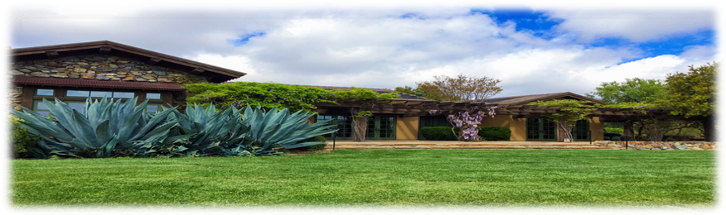
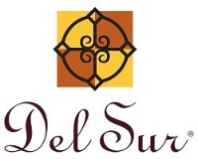
15455 Paseo Del Sur
San Diego, CA 92127
(858) 759-1921
February 28, 2020

Brush Management and Fire abatement utilizing Goats: The Brush Management utilizing Goats continues to progress a little slower than anticipated. This is due to a couple of setbacks experienced by the vendor.

The Goats will continue to work over the back of High Rose Park canyon, hopefully completing that area next week. They will then be turning their efforts and focus upon the canyons behind Old Stonefield Park and along the canyon towards Atkins Place. This stretch will take some time to get through as the brush is thick in a few places.

The Fire Marshal has been on-site to confirm the location required for the Shepherd’s quarters which comprises of two new caravans. The Fire Marshal requires the Shepherd’s quarters to remain within a certain proximity of the working goats for safety and security purposes. The caravans will only be situated for period of time until the brush management is completed. Please stay clear of the caravans thank you.

Please keep well clear of the Goats and working area, to include the electric fencing and Goat protecting dogs. While observing the Goats working from a far is fine, getting close to the fenced off areas is not.

Thank you in advance for respecting this request and your understanding, as Del Sur works through its brush management requirements for 2020.

Should you need to contact the Shepherd, please call Johnny Gonzales on 619 234-4555.

Dumping Trash into park receptacles: It has been brought to our attention that
people have been dumping their trash from their homes into the trashcans that
are located at the community parks. It is illegal to place garbage or litter into
someone else's garbage can or trash receptacle without the owners express
permission. Please refrain from bringing trash from home and dumping it into
these trashcans. It is causing an overflow of trash at the parks.

Park Reservation Reminder: Please be aware that we must receive your park agreement, payment and deposit, if applicable, (7) seven days prior to your reservation or your reservation will be canceled, no exceptions.

Just a reminder: After use of the park barbeque area, please ensure it is left in a clean and neat state for the next homeowners to use the area. Thank you.

General Manager

Darryn.Marshall@fsresidential.com
Facilities Manager
Charlie Mullins
Charles.Mullins@fsresidential.com

Assistant Manager
Chris Malama
Christine.malama@fsresidential.com

Administrative Assistant
Gigi Ochoa
Gigi.Ochoa@fsresidential.com

~~~~~~~~~~~~~~~~~~~~~~~~~~~~~~~

Del Sur Neighborhood Park
15816 Paseo Montenero
(Owned and operated by the City of San Diego)

For reservations, information or

to report an incident please call:
858-538-8131
~~~~~~~~~~~~~~~~~~~~~~~~~~~
ATLAS
Defense Group Patrol Services: On-Site Officer (3pm to 11pm) 619-490-0012
~~~~~~~~~~~~~~~~~~~~~~~~~~
Suspicious Activity:
San Diego Police Department
Non-Emergency Dispatch Line:
858-484-3154
FOR EMERGENCIES DIAL 9-1-1
~~~~~~~~~~~~~~~~~~~~~~~~~
San Diego County Animal Control:
619-767-2675
24-Hour Emergency:
619-236-2341 ~~~~~~~~~~~~~~~~~~~~~~
CUSTOMER CARE:
To Report After-Hours Issues, or Assessment Questions
(800) 428-5588

Community Services Council vs Del Community Association

Did you know that the CSC is independent from the Del Sur Community Association and both entities have their own areas of responsibility?

 |  | CSC | DEL SUR COMMUNITY ASSOCIATION
Boards |  | 5 Directors | 5 Directors
Purpose |  | - Funds & organizes all Community Events, including Movie Nights, Concerts, Holiday Events, etc.  - Promotes and supports resident Driven Community Clubs | - Upkeep and Maintenance of common areas: including private parks, mail boxes, etc.  - Enforcement of Covenants, Conditions and Restrictions  - Oversee Design Review
Source of Funds |  | Enhancement Fee on the Sale of homes in Del Sur | Monthly HOA Dues
Meeting Schedule |  | Meet quarterly – 4th Wednesday  – January, April, July & October (April & October are in the evening and open to CSC residents. | Monthly Executive Meetings:  Open Session Meetings:  Are now being held on the 4th Tuesday of every odd month (Jan, Mar, May, Jul, Sept, and Nov). See www.delsurcommunity.org for details
Fiscal Year |  | June – May | June - May
Website |  | www.delsurcsc.org – For all  Event and Reservation Information | www.delsurcommunity.org – For all Association related Information

AVARON:  FirstService Residential  Lisa Silva lisa.silva@fsresidential.com  5473 Kearny Villa Rd.,  #200 San Diego, CA 92123  Direct: 949-448-6130  CASSERO:  Packard Management Dee Waite dwaite@packard-1.com  9555 Chesapeake Dr., Ste. 202 San Diego, CA 92123  858-277-4305  GARRETSON:  FirstService Residential  Michelle Menne michelle.menne@fsresidential.com  5473 Kearny Villa Rd., #200  San Diego, CA 92123  direct: 858-657-2161  Lisa Crawford  lisa.crawford@fsresidential.com  858- 657-2196  SKYE:  Community Manager:  Elena Mendenhall elena.mendenhall@fsredidential.com  858-657-2194  Assistant: Judi Abdon  Judi.abdon@fsresidential.com  858-657-2186  5473 Kearny Villa Rd.,  #200 San Diego, CA 92123 | AUBERGE:  Keystone Pacific  Marty Ignacio  MIgnacio@keystonepacific.com  16775 Von Karman, Suite 100  Irvine, CA 92606  Direct: 619-798-9110  MANDOLIN I:  Prescott Management  Danielle Lizardi  dlizardi@prescottmgt.com  16880 W. Bernardo Dr., Ste. 200  San Diego, CA 92127  Direct: 858-946-0320  Kristen Saucedo (Assistant)  Kristen.saucedo@prescottmgt.com  MANDOLIN II:  San Diego HOA Management Inc.  Nick Bradley  nick@sdhoa.com  4025 Camino Del Rio S. #300  San Diego, CA 92108  858-227-4220 X 105  AVANTE’:  Christian Raymundo Christian.Raymundo@fsredidential.com  858-657-2186  Judi Abdon  Judi.abdon@fsresidential.com  858-657-2186  5473 Kearny Villa Rd.,  #200 San Diego, CA 92123  CALATLANTIC HOMES (LENNAR) HOMEOWNER HOTLINE:  (800) 509-4979  WILLIAM LYON HOMES CUSTOMER SERVICE  800-770-6883  BROOKFIELD HOMES HOTLINE  CALIFORNIA CUSTOMER CARE:  800-399-0490  CONTACT@CACUSTOMERCARE.COM | Board Members:  President:  Bill Ostrem  Vice President:  Lynn Miller  Director at Large:  Alex Plishner  Director at Large:  Ruth Loucks  Director at Large:  Hollie Kahn  BOARD MEETINGS  Executive Session:  The next meeting is scheduled for Tuesday, March 24, 2020 at 5:00 pm at the Ranch House.  Executive session meetings are closed to homeowners  Open Session:  Open session board meetings are now being held on the 4th Tuesday of every odd month (Jan, Mar, May, Jul, Sept, and Nov).  Next Open Session Meeting:  Tuesday, March 24, 2020  at 6:30 pm.  Design Review Committee:  Meetings are scheduled for the second Friday of each month with a deadline for submittal of the first Friday of each month. Please submit Variance Requests and supporting documents for all your minor exterior improvements to Chris Malama at christine.malama@fsresidential.com.
Please call Customer Care for any
after-hours emergencies at
(800) 428-5588. Management
hopes that everyone has
a safe and Happy Holiday!

