
April 23, 2026

Dear Del Sur Residents,

Friendly Reminder: Community Survey
A reminder to please check your email for the community survey regarding recent mailbox break-ins
that was distributed earlier this week.

We kindly ask all residents to take a few minutes to complete the survey by Wednesday of next week. Your feedback is important and helps guide upcoming community decisions and priorities.

Thank you in advance for your time and participation.

Responsible Pet Ownership & Courtesy
We’ve recently received several concerns regarding dogs barking for extended periods, including during overnight hours. We understand how disruptive this can be and want to assure residents that these concerns are being taken seriously and addressed when reported.

We kindly ask all pet owners to be mindful of their neighbors. Excessive or prolonged barking—especially late at night or early in the morning—can impact the comfort and well-being of those living nearby. If your dog tends to bark when left alone or during certain times, please consider steps to help minimize the noise, such as bringing pets indoors at night, using training techniques, or exploring tools designed to reduce barking.

As a general reminder, all dogs are required to be on a leash while in common areas, unless they are within designated off-leash dog park areas. We also encourage residents to take advantage of the community’s dog parks for exercise and socialization.

Additionally, please remember to always clean up after your pets. Waste stations are provided throughout the community for your convenience, and proper disposal helps maintain a clean and enjoyable environment for everyone.

For residents experiencing ongoing disturbances, we encourage continued documentation and communication with management. While response times from outside agencies may vary, reporting concerns helps us track patterns and take appropriate next steps.

Thank you for your cooperation and for helping keep our community a comfortable and welcoming place for all.

Safety Reminder: Fire Access & Parking Awareness
Following the recent brush fire in the community, we would like to take a moment to remind all residents of the importance of keeping roadways clear for emergency access.

Vehicles parked along main access points, narrow streets, or shared drive aisles can unintentionally create obstacles for emergency responders, including fire and medical personnel. In the event of an emergency, clear access is critical and can impact response times.

We kindly ask all residents to be mindful of where vehicles are parked and to utilize garages and driveways whenever possible. Please avoid parking in a way that may restrict access along key entry points or heavily traveled community areas like the Piazzas in Increment 2.

Your cooperation helps ensure that emergency services can safely and efficiently reach all areas of the community when needed.
Thank you for your attention to this important safety matter!

MANAGEMENT TEAM

General Manager

Darryn Marshall

Darryn.Marshall@fsresidential.com

Assistant Community Manager
Andrea Cameron
Andrea.Cameron@fsresidential.com
Architectural Design &
Ranch House Reservations

Facilities Manager
Silvio Lopez
Silvio.Lopez@fsresidential.com
Work Orders & Common Area Concerns

Administrative Assistant
Marilou Marcelo
Marilou.marcelo@fsresidential.com
Pool cards, Park Reservations, &Transponders

**************************************************

Ranch House Office
15455 Paseo Del Sur
San Diego CA, 92127
858-759-1921

Office Hours:
8:00 am – 4:30 pm
Monday – Friday
**************************************************
ALLIED UNIVERSAL SECURITY SERVICES
On-Site Officer (3pm to 11pm)
720) 916-7009
***************************************************
SUSPICIOUS ACTIVITY:
San Diego Police Department
Non-Emergency Dispatch Line:
619-531-2000
FOR EMERGENCIES DIAL 9-1-1

SDPD COMMUNITY RELATIONS
Officer John Briggs San Diego Police Department, Northwestern Division:
12592 El Camino Real, MS 782,
San Diego, CA 92130
Phone: (858) 523-7031
Email: jbriggs@pd.sandiego.gov
***************************************************
San Diego Humane Society
619-299-7012
***************************************************
CUSTOMER CARE: To Report After-Hour Issues, or Assessment Questions
(800) 428-5588
Customercare.ca@fsresidential.com

For all your billing information visit
CLICK PAY:
FirstService Residential | Online Monthly Payments (clickpay.com)

Del Sur Community Association
Mailbox Vandalism & Theft – Communication from your Board:

We are writing to you with a sincere and empathetic understanding of the frustration, concern, and disruption caused by the recent reports of mailbox vandalism and mail theft within our community. We recognize how important secure and reliable mail delivery is to your daily lives, and we want you to know that both the Del Sur Community Association Board of Directors and Management are actively working on your behalf to address this issue.

Understanding the Situation
Mailbox vandalism and mail theft are not isolated to Del Sur—they are occurring throughout San Diego, across California, and nationwide. These incidents are federal crimes and are most commonly associated with forced entry into mailbox components that are under the jurisdiction of the United States Postal Service (USPS), rather than those maintained by the Association.
That said, we fully acknowledge the impact this has on our residents and are committed to doing everything within our authority—and beyond through partnerships—to improve the situation.

What the Association Has Done
- The Association conducts routine inspections of all mailbox banks alongside landscape, park, and governing document inspections.
- The Association’s painting contractor performed an inspection of all 114 mailbox banks on February 4, 2026, and no vandalism affecting HOA-maintained components was identified.
- We have not received widespread reports of damage to HOA-responsible mailbox structures from residents or USPS.
- Any USPS-related issues observed have been reported accordingly.
- The Association continues to coordinate with USPS and document reported incidents.
- Inviting SDPD Community Officer Briggs to the Ranch House to meet with concerned residents.
Upcoming Community Improvements: Over the next 8 weeks, the Association will:
- Paint all mailbox banks (As part of the general maintenance program)
- Replace old numbering with new, updated numbers (As part of the general maintenance program)
- Evaluate installation of high-visibility signage warning that mail theft is a federal felony (up to $25,000 fines and/or imprisonment).
- Evaluate lighting at mailbox banks (solar) and (sensor).
Who Is Responsible for What? (Simple Guide)
To provide clarity, please refer to the simplified responsibilities below:
🏡 Del Sur Community Association
- Mailbox structures and pedestals and full replacement.
- Exterior painting and maintenance.
- Coordination of inspections and repairs (when within HOA scope).
- Reporting to USPS any reports received of damage and vandalism.
📬 United States Postal Service (USPS)
- Master access doors and locks (used by mail carriers).
- Parcel locker systems.
- Processing and completing repair work orders of the master lock.
- Mail delivery operations.
- Actioning upon receiving reports of Mail Theft and Mailbox break ins and vandalism.
🔑 Residents (Individual Responsibility)
- Your personal mailbox lock and key
- Replacement of individual locks (available through the Ranch House) Phone 858 759 1921
- Reporting Mail Theft and Mailbox break ins and vandalism to USPS and to Management at the Ranch House) Phone 858 759 1921

As a Resident of Del Sur Who Should You Contact?
To help ensure fast and proper response, please follow this guide:

Mailboxes - Formation of a Resident Ad Hoc Task Force
You may have received by now a letter from the HOA and your management company FirstService Residential providing an update on mailbox vandalism and mail theft prevention initiatives. Please note that even though the letter stated the deadline of 4/10/2026 to volunteer for the Ad Hoc Mailbox Task Force, you can still volunteer. This is the perfect opportunity to support your community by getting involved in addressing the matter of mailbox vandalism and mail theft prevention.
Following the discussion at the Del Sur Open Session Meeting on March 31, 2026, the Board is forming the Resident Ad Hoc Mailbox Task Force.

This group will:
- Collaborate with the San Diego Police Department and United States Postal Service
- Explore additional solutions and prevention strategies
- Help monitor trends and bring forward community-driven ideas
- Strengthen partnerships with government agencies, USPS and SDPD

Open Invitation to Participate in the Resident Ad Hoc Mailbox Task Force:
If you are interested in volunteering for this task force, please email:
Your General Manager Darryn Marshall darryn.marshall@fsresidential.com
Please include:
- Your contact details
- A brief statement explaining why you would like to participate
If you have any questions, please contact Darryn Marshall on 858 759-1921.

SDPD Recommendation: Please empty your mailbox out daily – Empty mailboxes can be our greatest defense and crime deterrent.

Thank you to those residents who have reported mailbox issues in the past to both USPS and to the management team at the Ranch House. We are please to report that we have not received any new reports of mailbox break ins this month.

We strongly believe that community involvement is key and a remedy to this issue.



- Individual mailbox lock issue (your own box):
→ Contact the Del Sur Ranch House / HOA Management Phone 858 759 1921
- Mailbox broken into / main door forced open / multiple boxes impacted:
→ Contact USPS at 1-800-ASK-USPS (1-800-275-8777)
→ Also notify HOA Management with the exact location
- Active vandalism or suspicious activity:
→ Call 911 or the San Diego Police Department (858) 523-7031
→ Report to USPS Postal Inspectors

Strengthening Prevention – What We Are Researching
The Board & Management are actively researching and evaluating best practices used by communities across the country, including:
- Enhanced lighting and surveillance systems
- License plate reader technology
- Improved signage and deterrents
- Resident awareness campaigns
- Strategic mailbox placement and usage education
These strategies focus on deterrence, visibility, and community participation, which have proven to be the most effective approach.

Formation of a Resident Ad Hoc Task Force
Following the discussion at the Del Sur Open Session Meeting on March 31, 2026, the Board is forming a Resident Ad Hoc Mailbox Security Task Force.
This group will:
- Collaborate with the San Diego Police Department and United States Postal Service
- Explore additional solutions and prevention strategies
- Help monitor trends and bring forward community-driven ideas
- Strengthen partnerships with government agencies

We strongly believe that community involvement is key to solving this issue.

Invitation to Participate If you are interested in serving on this task force, please email:
Darryn Marshall darryn.marshall@fsresidential.com
Deadline: Friday, April 10, 2026, at 4:00 PM
Please include:
- Your contact details
- A brief statement explaining why you would like to participate

Additional Action
As part of our continued efforts, Darryn Marshall your General Manager will personally be making another visit to the USPS facility at:
Rancho Bernardo Annex
16960 Bernardo Center Drive
to meet with the Postmaster and learn:
- What other communities are doing
- How USPS can further support Del Sur
- Opportunities for stronger coordination with law enforcement
Anyone selected to form the ad hoc task force committee is more than welcome to attend.

Final Thoughts
We understand how unsettling these incidents are. Please know that your Board and Management team are:
- Taking this matter seriously
- Acting within our authority
- Advocating for stronger external support
- Working toward both short-term response and long-term prevention

This is a shared challenge across communities, but with coordinated effort between residents, HOA, USPS, and SDPD law enforcement—we can make meaningful progress.
Thank you for your continued vigilance, cooperation, and commitment to keeping Del Sur a safe and thriving community.

Updates from USPS
The Postal Supervisor confirmed that the mailboxes reported as “tampered” or “vandalized” are primarily experiencing lock issues. USPS processes all repair work orders, which typically take 1 to 3 months to complete. While awaiting repairs, the mail carrier will place a notice on the affected mailbox bank. Residents using that location will need to collect their mail directly from the Rancho Bernardo Annex during the hours listed above. USPS has reported that some repairs have already been completed, and they continue to work through pending requests.
How You Can Help
- Report damaged or tampered mailboxes to the Ranch House management team and also to USPS with the exact location.
- Collect and empty your mailbox daily to prevent a build up of mail. Empty mailboxes will also deter criminals.
- Be alert for suspicious activity near mailbox banks and report immediately to:
  - San Diego Police Department: 911
  - USPS Postal Inspectors: 📞 1-800-ASK-USPS (1-800-275-8777) to report damages/vandalism/mail delivery issues.
Tampering with or interfering in the delivery of U.S. Mail is a federal offense.
Moving Forward
The Del Sur Community Association has taken all possible steps on behalf of residents and will continue to partner with USPS to push for faster repairs and improved communication.
For additional questions or concerns regarding mailbox security and repairs, please contact:
📞 USPS at 1-800-ASK-USPS (1-800-275-8777). Thank you.

Voted the most effective mailbox crime prevention signage across the Nation, and the type of signage being sort for the 114 mailbox banks throughout the Del Sur Community.
.


Swim Lessons Season Returns: April 15, 2026 – October 15, 2026

*ALL pools are heated during the Swim Lesson Season ONLY

Pools heated year-round:
- Kristen Glen
- Jacqueline
- Angeline

Swim Season is well underway! Typically, San Diego has a cold start to summer but this year the heat seems to be off to an early start. The HOA continues to make every effort to keep all the pools heated to 82 degrees with the gas and solar systems at each pool.
The Del Sur Community Association thanks everyone for their understanding.

Please do not forget to fill out the swim lesson waiver and drop it off at the Ranch House or email it to: Andrea.Cameron@fsresidential.com
The waiver can be found on the Del Sur Community website (www.delsurcommunity.org).

The following is a list of the approved swim lesson instructors. For further swim lesson information, please see the Del Sur Community Association Swimming Lesson Policy Effective March 1, 2024, below.

- AquaSafe Swimming aquasafenow@gmail.com
Website: aquasafeswimming.com
Office #: (619) 531-8888
- Kris Jeynes jacksonskris@yahoo.com
- Lara Gillman Laralean1@gmail.com
- Sun Min Kim banaba1004@hotmail.com
- Nicole Raimondi Admin@swimbabyswim.com
Website: www.Swimbabyswim.com
- Swim with Elly ms.ellygergove@gmail.com
Website: www.swimwithelly.com

Del Sur Community Association
SWIM LESSON POLICY
EFFECTIVE 3/1/2024

Del Sur Community Association (“Community Association”) Board of Directors recognizes that learning to swim facilitates the use and enjoyment of the Community Association’s pools and reduces the risk of injury by pool users, Therefore the Board has determined that it is in the best interest of the membership to allow limited swim lessons to be conducted, subject to this Swim Lesson Policy (“Policy”).

This Policy has been established to enable owners and residents to receive swim lessons within the community while protecting the right of all owners and residents to use the Community Association pools and minimizing the risk of liability for the Community Association.

***The pool temperature will be set to 82°. Please note this temperature can and will fluctuate depending on weather conditions and time of day. If the water is too cold for lessons that day the swim instructor or participant/ guardian should reschedule the lesson for another day.***

The Board has decided to charge a usage fee and a security deposit for the use of Del Sur Pools for swim instruction each season.

Usage Fees:

- The Policy requires that each instructor be required to pay a non-refundable usage fee of $250 before commencement of lessons each season to assist with the maintenance and operations of the pools the instructors use.
- Each instructor will also be required to pay a refundable* $250 security deposit before commencement of lessons each season. Security deposits will be refunded at the end of the season. **CONDITIONS APPLY see below**

In the event any owner or resident is found to have violated this Policy, they may, after notice and hearing, be prohibited from participating in any future swim lessons within the Community Association. They may also be subject to other disciplinary action as discussed below.

- In the event any person is found teaching swim lessons in violation of this Policy, they may be permanently prohibited from providing swim lessons at the Community Association’s pools.

- In the event any instructor is found in violation of this Policy, the instructor shall forfeit his/her security deposit.

- Swim lessons shall only be permitted at the following Community Association pools: Beltaire, Reagan Glen, Old Stonefield, Jacqueline, and Trent (“Designated Pools”). Under no circumstances shall a Community Association pool other than a Designated Pool be used for swim lessons.

- Swim lessons shall only be permitted at Designated Pools from:
April 15th- October 15th

- Conducting swim lessons outside of the Swim Season is prohibited.
(i.e., April 15th- October 15th)

- Swim lessons shall only take place at Designated Pools during the following hours:

  - Monday through Friday, excepting national holidays: 6:00 a.m. to 6:30 p.m.
  - Saturdays and Sundays, excepting national holidays: 8:00 a.m. to 12:00 p.m.
  - National holidays: No swim lessons permitted.

- The Community Association will authorize no more than seven (7) swim instructors to conduct swim lessons at the Designated Pools each Swim Season (“Authorized Swim Instructors”). Only Authorized Swim Instructors shall provide swim lessons at the Designated Pools. In the event a swim instructor ceases to be an Authorized Swim Instructor during a Swim Season, as discussed in Provision 8, below, the Community Association may authorize another swim instructor to take his or her place for the remainder of the Swim Season.

- To prevent swim lessons from unreasonably interfering with the use of the Designated Pools by other owners and residents, as well as for safety reasons:

  - Only one Authorized Swim Instructor shall be permitted to use a Designated Pool for swim lessons at a time.

  - An Authorized Swim Instructor must reserve in advance a Designated Pool for any time that Authorized Swim Instructor proposes to provide a swim lesson (“Scheduled Lesson”). A reservation is made by contacting the Community Association’s management office and receiving confirmation from the management office that the Designated pool is booked for his or her use on a specific date and time.

  - An Authorized Swim Instructor may schedule the use of a Designated Pool for swim instructions during the Swim Season for a maximum of four (4) hours per day, subject to d, below.

  - An Authorized Swim Instructor may schedule the use of a Designated Pool for swim instructions during the Swim Season for a maximum of four (4) days per calendar week.

  - Notwithstanding c and d above, in the event there are fewer than seven (7) Authorized Swim Instructors during any portion of the Swim Season, the Community Association may permit the other Authorized Swim Instructors to schedule additional swim lessons to compensate for the reduced number of Authorized Swim Instructors. The total additional Scheduled Lessons the Authorized Swim Instructors may collectively give shall not exceed sixteen (16) hours per calendar week for each vacant Authorized Swim Instructor position. Additional Scheduled Lessons shall be authorized on a first come, first serve basis.

  - An Authorized Swim Instructor shall only provide instruction to one student at a time. Multi-student lessons are prohibited.

  - An Authorized Swim Instructor must notify both the Community Association office and his or her student if he or she cancels a Scheduled Lesson. The Community Association shall not be responsible for providing this notice.

  - A student must notify his or her Authorized Swim Instructor if he or she cancels a Scheduled Lesson. The Community Association shall not be responsible for providing this notice.

  - An Authorized Swim Instructor shall only provide swimming instruction to Community Association owners and residents. At no time shall any Community Association pool be used to provide swim instruction to persons other than Del Sur owners and residents.

  - An Authorized Swim Instructor cannot be in the pool area except when providing a scheduled lesson.

  - Only one lane at the Jaqueline pool shall be used for swim lessons at any time.

  - In the event a Designated Pool is closed unexpectantly for maintenance or for any other reason at the time of a Scheduled Lesson, the Authorized Swim Instructor shall reschedule that lesson.

  - Under no circumstances shall an Authorized Swim Instructor provide swim instruction outside of a Scheduled Lesson.

  - Under no circumstances excepting an emergency shall an Authorized Swim Instructor use a cellphone while providing a swim lesson at a Designated Pool. For the purpose of this Policy, an emergency is a situation that poses an imminent threat to the health or safety of any person(s) or an imminent threat of property damage.

  - Under no circumstances, excepting an emergency necessitating all persons to leave the water (e.g. a chemical spill; fecal matter in the pool), shall an Authorized Swim Instructor attempt to keep other persons from using the pool during a Scheduled Lesson. A Designated Pool shall remain open for general use during a Scheduled Lesson.

- Eligibility requirements for becoming an Authorized Swim Instructor are as follows:

  - The swim instructor must notify the Community Association’s office of his or her interest in becoming an Authorized Swim Instructor.

  - The swim instructor must provide evidence to the Community Association that he or she has obtained and maintains liability insurance as required by the Community Association.

  - The swim instructor must enter into an agreement with the Community Association wherein he or she agrees, among other things, to at all times maintain the required insurance and comply with this Policy (“Swim Instructor Agreement”).

  - The swim instructor must submit a signed instructor waiver for themselves.

  - The swim instructor must submit a signed Student Waiver for each student they will be providing swim instruction to.

  - The swim instructor must not have previously violated this Policy.

The Community Association/ Management team is not qualified to evaluate the skill level of swim instructors and does not do so. Nor does the Community Association/ Management team perform background checks. By authorizing a swim instructor, the Community Association/ Management team only warrants that he or she has complied with a, b and c above, and that to the best of the Community Association’s knowledge, he or she has not violated f above.

- It shall be the responsibility of Del Sur owners and residents to:

  - Evaluate an Authorized Swim Instructor’s qualifications and skill level.

  - Schedule their swim lessons with an Authorized Swim Instructor.

  - Negotiate any payment amounts and terms for their lessons.

  - Pay the Authorized Swim Instructor’s fee when due.

Notwithstanding the foregoing, under no circumstances shall an owner or resident negotiate terms for a swim lesson that are in violation of this Policy.

Owners and residents may obtain a list of Authorized Swim Instructors and their contact information from the Community Association’s office. This list is also available on the Community Association’s website.

- The Community Association may rescind a swim instructor’s designation as an Authorized Swim Instructor if that swim instructor violates any terms of the Swim Instructor Agreement or violates any provision of this Policy.

- Any person found to be using an Unauthorized Swim Instructor or otherwise violating this Policy may be called to hearing whereat a fine may be imposed, the costs of addressing his or her violation, including any attorney’s fees incurred, may be imposed, and/or his or her right, along with the right of all other persons associated with his or her property, to use the Community Association recreational facilities, including the pools, may be suspended. (Please see the Community Association’s Enforcement Guidelines.)

- Complaints regarding an Authorized Swim Instructor or violations of this Policy should be promptly reported, in writing, to the Community Association’s management office for investigation.

- The Community Association reserves the right to rescind the approval to allow swim instruction within Del Sur.

The Del Sur Community Association Board of Directors adopted this Policy at its duly noticed February 28th, 2024 Board Meeting. This Policy is now in effect.

Del Sur Community Association Board of Directors

Suspicious Activity
As we enter the summer season, we typically see an increase in unauthorized use of community amenities, particularly the pools. We kindly ask all residents to remain vigilant and report any suspicious activity.
There have been recent incidents involving individuals, often teenagers, accessing the pool areas without authorization and leaving behind litter. To help maintain the safety and cleanliness of our shared spaces, please contact the non-emergency police line at (858) 521-5200 if you observe anyone who does not appear to be a member of the Del Sur community entering pool areas or other community facilities. Unauthorized entry is considered trespassing, and your assistance in reporting these incidents is greatly appreciated. Thank you for your cooperation.

Unleashed Dogs
For the safety and comfort of all members of our community, including out four-legged friends, we kindly remind all pet owners to keep their dogs on leashes when outside their homes. Leash laws help:
- Ensure the safety of your pet
- Prevent unwanted encounters with other pets or residents
- Keep our shared spaces clean and enjoyable for everyone
Thank you for being a responsible pet owner and helping us maintain a peaceful and welcoming neighborhood!

Trash
Please also note that trash containers cannot be placed out for collection on the street, curb or sidewalks before 6 p.m. the day before a regular collection day; or be left out after 6 p.m. on a regular collection day, except for within the Central Traffic District area, where the containers cannot be placed out before 6 a.m. on a regular collection day; or left out after 10 a.m. of that same day; or one hour after collection on that same block, whichever is later. See San Diego Municipal Code, Chapter 6, Article 6, Division 1. To determine the regular collection day for your address, if you receive City refuse collection service, go to: https://getitdone.force.com/ESDTrashCollectionSchedule. General information regarding City refuse collection services and eligibility criteria can be found at: www.sandiego.gov/environmentalservices/collection/general

Recycling
Recyclables, as defined, are required by law to be placed into an approved recycling container. See San Diego Municipal Code, Chapter 6, Article 6, Division 7. To determine what materials are recyclable, go to: www.sandiego.gov/sites/default/files/what-goes-where.pdf. Recycling containers should be placed out for collection on the street, curb or sidewalks at the same time as the trash containers, in accordance with the biweekly recyclables collection schedule. To determine the regular collection day for your address, if you receive City recycling collection service, go to: https://getitdone.force.com/ESD_TrashCollectionSchedule. General information regarding City recycling collection services and eligibility can be found at: www.sandiego.gov/environmentalservices/recycling/residential/curbside

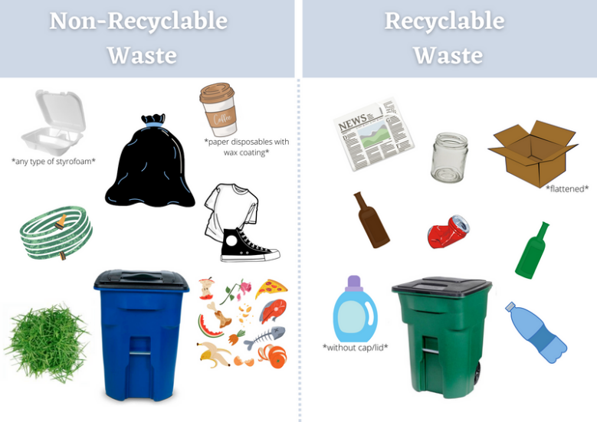

Friendly Reminder: Drive Safe in Del Sur

Just a quick reminder to please observe all posted speed limits while driving through the community. We also kindly ask that you remind any guests or vendors visiting your home to do the same. Thank you for helping keep Del Sur safe and enjoyable for everyone!



E-Bikes

Motorists, please keep an eye out for riders. If your child has an E-Bike or standard bicycle, please make sure your child/children are being safe, taking care around parked vehicles and using bicycle lanes. Be safe be seen at night. For their safety, turn this into a teaching moment for them. Speak to them about how dangerous it can be to have multiple riders and what could happen if one of their friends is injured while they are driving. Please also talk to them about the dangers of speeding through the community, through intersections, around the town center, including up through the Ranch House area. Thanks in advance parents for your assistance, as we look out together for our precious kids of Del Sur.

To see California E-Bike Policy Explained and E–Bike safety Ctrl + click the following link.
eBike Classifications and Laws – San Diego County Bicycle Coalition (sdbikecoalition.org)
This following website is a great resource from the City of San Diego,
https://www.sandiego.gov/bicycling/bicycle-and-scooter-sharing
Ctrl + click the following link for regulations on E-Bikes
- Alternative Vehicle Information: Familiarize yourself with San Diego Police Department information and regulations on using alternative vehicles, including motorized scooters, mopeds and motorized bicycles, electric bicycles, and electronically motorized boards.

We have noticed an uptick in damages from E-bike/ bike usage throughout the community in private easements, & in open spaces behind homes that is causing maintenance issues and unnecessary expenses.

We are asking parents to please make sure your child/children understand the importance of following the rules of the road, using bike lanes, staying out of private property, & using caution around parked vehicles while operating their E-bikes. Please talk to them about the dangers of speeding through the community when crossing streets, intersections, & driveways, including up through the Ranch House parking lot. Additionally, for the safety of the rider and patrons of the pool, E-bikes should NOT be used or stored in the pool areas.
Thank you ever so much for your cooperation and collaboration with this issue.

Del Sur Community Association Vs. Del Sur Community Services Council CSC
Firstly, we would like to wish you all a very Happy Harvest Festival! Woo Hoo! Throughout the week, management has received a lot of phone calls with questions regarding the Fall Festival. Please keep in mind that the Del Sur Community Association and Del Sur Community Services Council are two separate entities. The contact for all events is the CSC Community Services Council is info@delsurcsc.org

Del Sur Distribution List
Management would like to remind residents that if you are planning to move or are in the works to move out of the Del Sur Community, please let us know by emailing delsurcommunity.ca@fsresidential.com so that we may remove your email from our newsletter and update the distribution list.


Crime Prevention Tips
Please remember to use the following numbers to report crimes in progress.
Non-Emergency Dispatch Line: 619-531-2000 or (858) 484-3154
FOR EMERGENCIES and if you feel threatened or in danger DIAL 9-1-1
Community Relations Officer John Briggs has provided his contact information and would like for homeowners/ Residents to reach out to him with any questions, concerns, or any information with regards to safety and crime prevention.

His contact information is as follows:
Officer John Briggs San Diego Police Department, Northwestern Division:
12592 El Camino Real, MS 782, San Diego, CA 92130
Phone: (858) 523-7031
Email: jbriggs@pd.sandiego.gov

Homeowners/ Residents can protect their homes and help protect their neighbor’s homes by making some simple changes. Here are some tips from the San Diego Police Department:

- Report suspicious activity to the San Diego Police Department immediately using the contact info above.
- Do not leave valuables in cars, always double check the doors are locked before entering the house.
- Have a neighbor pick up your delivered packages so they are not left in full view.
- Make sure you are aware of your surroundings. Double-checking things are put away and locked up.
- Install timers that turn on lights in different windows at different times.
- Install deadbolts to all doors that enable entry, including upstairs where entry can be gained.
- Install/ update alarm system and set it anytime you are away from home.
- Install glass break sensors on windows and doors on all floors.
- Install motion sensors on all floors and windows.
- Stop mail delivery and package deliveries while on vacation.
- Install security cameras outside your home.
- Notify the local police department or a trusted neighbor when you are going to be away.
- Use outdoor lighting. Light up dark spot in your yard. For pennies per night, it adds security to your home and the surrounding area. Please submit your variance request through the HOA.
- Do not let any service representative into your home without proper identification.
- Contact Officer Briggs to organize a security inspection of your property and home. This service will help to provide crime prevention initiatives/solutions directly related and relevant to your own home.
- Officer Briggs is also available to set up a meeting with neighborhood reps or residents that would like to form a neighborhood watch group in their community.

Please be advised that the Association employs a person to periodically patrol the Association’s Community Common Area between the hours of 3:00pm- 11:00pm. The primary purpose of this patrol person is to discourage Community Common Area loss and enforce the governing documents, as well as assist the Association and law enforcement in the identification of perpetrators of crime.

The purpose of this patrol person is not to provide security services to the residents or private property. The Association does not provide security services to the residents. Nor does the Association ensure or guarantee the safety of persons or property. All residents within the Del Sur community are responsible for providing for their own safety and security.

So, it is important for all of us to remember to undertake our own reasonable safety precautions, such as locking our doors and windows, routinely closing the blinds and drapes in our bedrooms and bathrooms when these rooms are in use (even if these rooms are not readily visible from the street), instructing our children on what to do if approached by anyone, not leaving valuables unattended in vehicles and the Community Common Area, locking our vehicle doors, and staying alert to our surroundings, especially when walking or jogging at night.

It is up to all of us to discourage criminal conduct in our community. The best way for us to accomplish this objective is to be observant and notify the police as soon as we witness any suspicious activity.

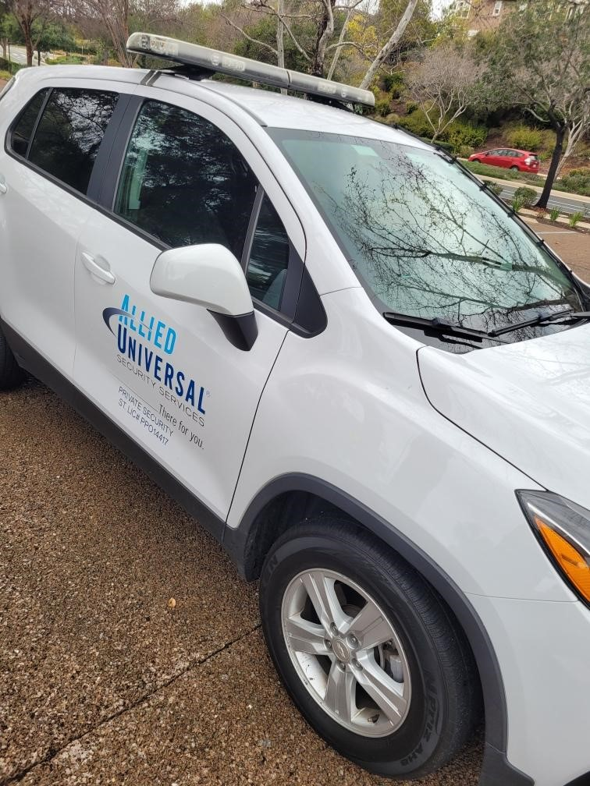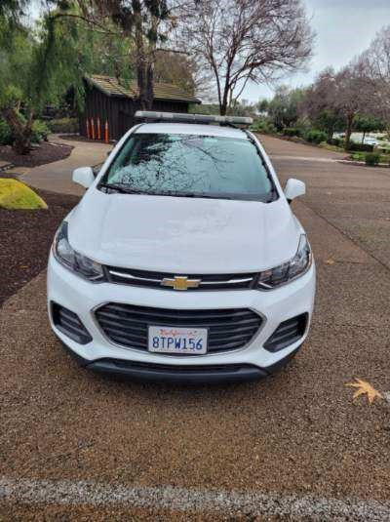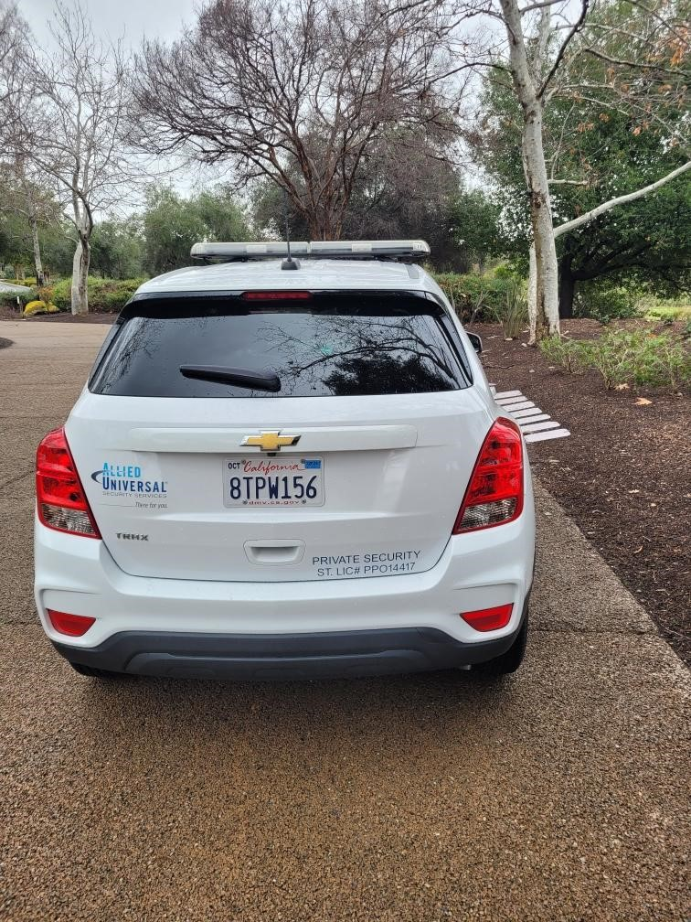
Neighborhood Representatives

Did you know you can contact your neighborhood representative regarding any matter of concern in your neighborhood? Your neighborhood rep can then get in touch with the Del Sur Community Association wither through management or by bringing the matter before the Board in an open session meeting. Open session meetings are held on the months of January, March, May, July, September, and November. Please see times and dates for all the association meetings on the last page of this bulletin. The following table provides all the neighborhood representatives and their contact details. Should you need any assistance with determining who your neighborhood rep is, please contact your management team at the Ranch House 858-759-1921.
ALCALA  Del Sur Board President  Chad Ross  Chadross0075@gmail.com | ARTESIAN RIDGE  Del Sur Board President  Chad Ross  Chadross0075@gmail.com | AVANTE  Avante Board President  Joe Adamczyk  jfadamczyk@outlook.com | AVION  Del Sur Board President  Chad Ross  Chadross0075@gmail.com
AVONDALE  Sarah Fontana  707-486-8905  sarahkeeter@hotmail.com | BRIDGEWALK  Glenn Holtz  760-518-3511  gcholtz@aol.com | CABRILLO  Zehra Rizvi  858-779-4988 (TEXT ONLY)  zrizvi@hotmail.com | CARLETON  Rob Seidenwurm  858-774-8859 rseidenwurm@gmail.com
CARILLO  Ashwin Mohan  ashwin.mohan@gmail.com | CASSERO  Cassero Board President  Mike Smith s-michael@att.net | DESCANSO  Tracee Kelley Eger  traceeandmarkeger@gmail.com | ESTATES  Lindsy Cabaniss  theestatesrep@gmail.com
GARRETSON  Garretson Board President  Johnny So | HAWTHORNE  Tova Steinhauser  CONTACT HOA | KENSINGTON  Sundaram Nagaraj  858-752-3178 (TEXT ONLY) | KINGSTON  Diana Fakhrai-Poorman  dianafakhrai@gmail.com
MADEIRA  Jessica Coffman  coffmanfamily06@gmail.com | MARSTON  Som Shahapurkar  Facebook Messenger https://www.facebook.com/som.shahapurkar  som.shahapurkar@gmail.com | PASADO  Keith Schneringer  Keith.schneringer@gmail.com | PRADO  Shalini Bansal  (732) 688-8992  krish_gupta@yahoo.com
PRESIDIO  Del Sur Board President  Chad Ross  Chadross0075@gmail.com | PRESTON  Jon Weis  jonweis@gmail.com | SENTINELS  Dan Otto  danny372005@yahoo.com | SKYE  Board President  Molly Putnam  mematyas@gmail.com
STRATFORD  June Cutter  junecutter@gmail.com | SUR33  Viet Thanh Ho viet.hothanh@gmail.com | VALENCIA  Vishva Lakshman Grimes  vishva.lakshman@gmail.com
DEL SUR PARKS
ANGELINE PARK  15899 Angeline Pl  Pool / Spa / Small lap lanes & Play Structure  (HEATED YEAR-ROUND) | AUBREY PARK  15919 Potomac Ridge Rd  Park/ Play Structure ONLY | BELTAIRE PARK  8455 Warden Lane  Pool/ Bocce Ball  (SWIM LESSON POOL) | HAALAND GLEN PARK  15998 Canton Ridge  Pool / Spa
HIGH ROSE PARK  15675 S. Chevy Chase  Pool / Spa & Play Structure  (SWIM LESSON POOL) | JACQUELINE PARK  15535 Tanner Ridge Rd  Pool / Spa / Small lap lanes  (SWIM LESSON POOL)  (HEATED YEAR-ROUND) | KRISTEN GLEN PARK  15770 Concord Ridge Terrace  Lap Pool & Spa  (HEATED YEAR-ROUND) | MEL DRISCOLL PARK  15735 Concord Ridge Ter.  Pool/ Play Structure
OLD STONEFIELD  15855 Kristen Glen  Pool & Dog Park  (SWIM LESSON POOL) | REAGAN GLEN PARK  8300 Parkside Crescent  Pool  (SWIM LESSON POOL) | SPRECKELS PARK  15725 Paseo Montenero  Park Only | TRENT PARK  15890 Trent Place  Pool / Wading Pool & Half Basketball Court
VILLAGE GREEN  Potomac Ridge Road  Stage on one side of park | WADE PARK  15790 Tanner Ridge Rd  Pool/ Splash Pad & Play Structure | DEL SUR NEIGHBORHOOD PARK  Owned, Operated and Maintained by City of San Diego  15816 Paseo Montenero  For Reservations, information, or to report an incident please call: 858-538-8184

Community Services Council vs Del Sur Community Association

Did you know that the CSC is independent from the Del Sur Community Association and both entities have their own areas of responsibility?
 | Del Sur Community Association | Design Review Committee (DRC) | Community Services Council (CSC)
Boards | 5 Directors | 4 Committee Members & Architectural Consultant | 5 Directors
Purpose | - Upkeep and Maintenance of common areas: including private parks, mailboxes, etc.  - Enforcement of Covenants, Conditions and Restrictions  - Oversee Design Review | - Review design submissions to ensure they are in line with the esthetics of Del Sur Community | - Funds & organizes all Community Events, including Movie Nights, Concerts, Holiday Events, etc.  - Promotes and supports resident Driven Community Clubs
Source of Funds | Monthly HOA Dues | N/A | Enhancement Fee on the Sale of homes in Del Sur
Meeting Schedule | Monthly Executive Meetings: Held every 4th Wednesday of every month  Open Session Meetings:  Are now being held on the 4th Wednesday of every odd month (Jan, Mar, May, Jul, Sept, and Nov). See www.delsurcommunity.org for details. | Monthly Meetings are scheduled for the second Tuesday of each month at 5 p.m. with a deadline for submittal of the first Monday of each month. | Meet quarterly – 4th Wednesday  – January, April, July & October (April & October are in the evening and open to CSC residents.
Fiscal Year | June - May | June- May | June – May
Website | www.delsurcommunity.org – For all Association related Information | www.delsurcommunity.org – For all Association related Information | www.delsurcsc.org – For all  Event and Reservation Information

Your DRC

Committee Chair

Carrie Walden

Secretary

Ruth Loucks

Committee Member

Jessica Coffman

Committee Member

Lori-Ann Stevens

Architectural Consultant

Jim Taylor

Your Board

President

Chad Ross

Vice President

Ruth Loucks

Treasurer

Michael Margro

Director at Large

Tripti Ranka

Secretary

Erick Caldwell

BOARD MEETINGS

All meetings are held at the Ranch House
15455 Paseo Del Sur,
San Diego CA 92127

Executive Sessions 2026

Executive session meetings are at
5:30 P.M.
Closed to homeowners.
April 29, 2026
May 27, 2026
June 24, 2026
July 22, 2026
August 26, 2026
September 23, 2026
October 28, 2026
November TBD, 2026
December TBD

Open Sessions 2026
Open session meetings are at
6:30 P.M.
Open to homeowners.

April 29, 2026
May 27, 2026
July 22, 2026
September 23, 2026
November TBD, 2026

Design Review Committee

Meetings are scheduled for the second Tuesday of each month at 5 p.m. with a deadline for submittal of the first Monday of each month.

SUB ASSOCIATION MANAGEMENT CONTACTS

Your Builder’s Contact Information

CALATLANTIC HOMES (LENNAR) HOMEOWNER HOTLINE:
(800) 509-4979

WILLIAM LYON HOMES CUSTOMER SERVICE
800-770-6883

BROOKFIELD HOMES CALIFORNIA CUSTOMER CARE HOTLINE:
800-399-0490
contact@cacustomercare.com

MANDOLIN I
Prescott Management
Breecia Hartman
BHartman@prescottmgt.com
16880 W. Bernardo Dr., Ste. 200
San Diego, CA 92127
Direct: 858-946-0320

MANDOLIN II
San Diego HOA Management Inc.
Taylor Fettel
Taylor@sdhoa.com
4025 Camino Del Rio S. #300
San Diego, CA 92108
858-227-4220 X 105

SKYE
Community Manager:
Zoe Castelblanco
Zoe.castelblanco@fsresidential.com
3131 Camino Del Rio N #230, San Diego, CA 92108
858-657-2175

AVANTE’
Prescott Management
Mike Pereira
619-230-1891
mpereira@prescottmgt.com
9610 Waples St.
San Diego, CA 92121
858-946-0320

Raul Hernandez (Assistant)
RHernandez@prescottmgt.com
AVARON
First Service Residential
Wade Andre
wade.andre@fsresidential.com
3131 Camino Del Rio N #230, San Diego, CA 92108
Direct: 858-657-2173

CASSERO
Packard Management
Josh Steinbock
josh@packard-1.com
8775 Aero Dr., Ste 335
San Diego, CA 92123
858-277-4305 Ext.222

GARRETSON
My Day
Melina Ortega
Melina@MyDayManagement.com
2659 State Street
Carlsbad, CA 92008
direct: 760-239-6624
800-361-8921

AUBERGE
Action Property Management
Justin Goodman
jgoodman@actionlife.com
7921 Auberge Circle San Diego, CA 92127
Office | 619-377-8117

